Noah L. Schrick

1492657

Case Study 5

Instructor: Dr. Ismail Abdulrashid
Instructions: Please read the instructions carefully!
For this case study, you can use LUCID Charts!
- Submit thru Harvey drop box
- Deliverable: You are expected to submit
  - A single word file (this file) that you have all your answers (use lucid charts for your answers).
- Check the Due Date Reported on Harvey!
Student Names: |  |  |  | Group:
 | Available Score | Deductions | Your Score | Comment
Presentation/ Design | 4
A | 21
B | 9
C | 21
D | 10
E | 10
F | 10
G | 15
Total | 100
Problem | Solution
- Create ERDs for the following.  a. A guest must stay in one room, but a room can house zero to many guests.  b. A hotel can host zero to many guests and a guest can be hosted in one to many hotels.  c. A garment belongs to one and only one category, but a category can include zero to many garments. | 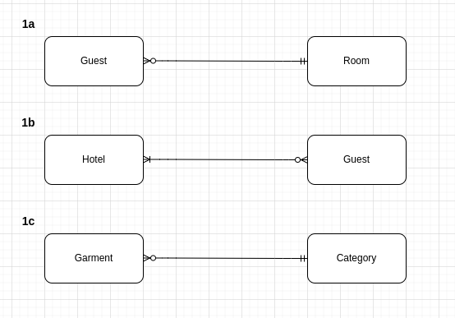

Problem | Solution
B. Read the following ERDs from left to right and from right to left. | 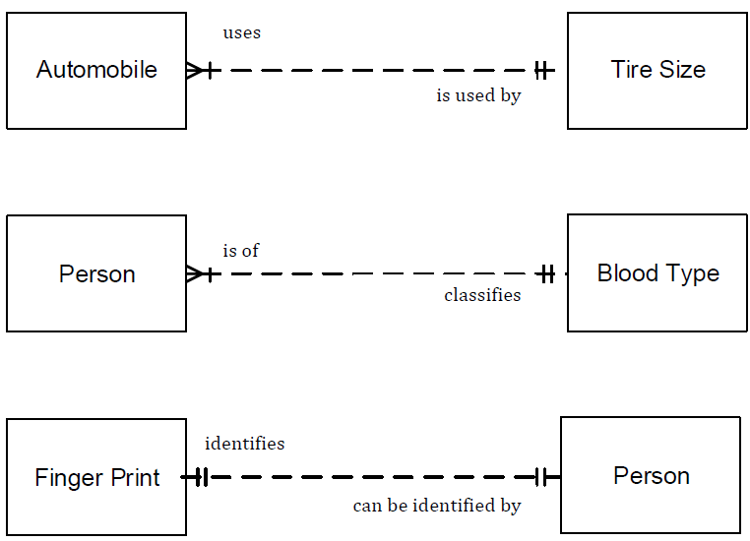  a) An automobile uses one and exactly one tire size, and a tire size is used by one to many automobiles.  b.) A person is of one and exactly one blood type, and a blood type classifies one to many people.  c.) A finger print identifies one and exactly one person, and a person can be identified by one and exactly one finger print.

Problem | Solution
C. Create ERDs for the following.  - A course may have no textbook or several; a given textbook is used in one and only one course.  - An instructor may teach several courses, but each course is taught by one instructor.  - A course has several sections; each section pertains to only one course. | 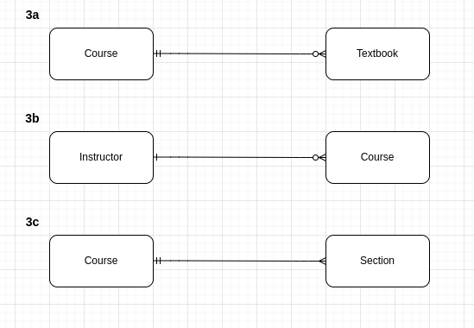

Problem | Solution
D. A student can enroll in many courses and a course can have many students. A student earns a grade in each course (Create ERD). Assign appropriate PKs and FKs for all entities-  Student ID (PK)  Course ID (PK)  Hint: There will be three entities!  Hint2: Use lucid charts to draw EDRs similar to:  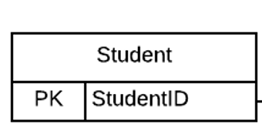 | 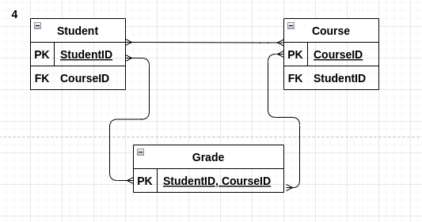
E. Diagram the following entity. The entity Zoo Animal has the following attributes: AnimalID (primary key), SpeciesID (foreign key), LocationID (foreign key), Name, DOB (date of birth), Age (calculated from the animal’s date of birth), and FavoriteFood.  Use Entity with all keys and attributes:  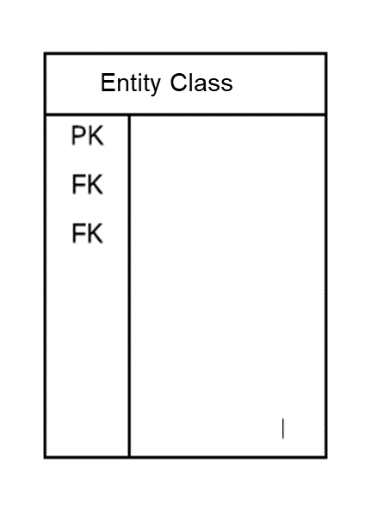 | 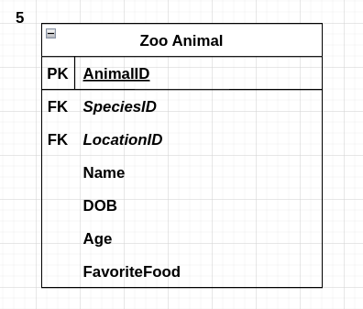

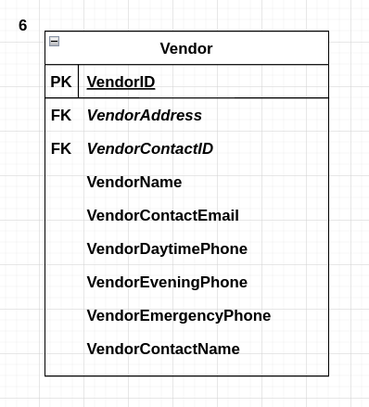  Problem | Solution
F. Diagram the entity, including attributes, for the following. A company keeps track of its vendors.
For each vendor, the company records the
vendor’s name and address, the contact person name, the contact person’s email address, and all relevant phone numbers for the company.
Use Entity with all keys and attributes:
G. The Marathoner, a monthly magazine, regularly reports the performances of professional marathon runners. They want a database to record results of major marathons (e.g., Boston, London). Pro runners compete in several races each year. A race may have thousands of runners, but only about 200 are professionals and are tracked by the magazine. For each race, the magazine records the runner’s time and finishing position, some personal details (name, gender, age), and race details like conditions,
number of competitors, and date (Create ERD).

Hint: There will be three entities!
Hint2: Use Entity with all keys and attributes:

