QM-7063 Data Mining
Professor: Dr. Abdulrashid
Learning Practice 5 – Noah L. Schrick

Imports and Initial Work
# Learning Practice 5 for the University of Tulsa's QM-7063 Data Mining Course
# Prediction and Classification Methods
# # Professor: Dr. Abdulrashid, Spring 2023
# Noah L. Schrick - 1492657

%matplotlib inline
from pathlib import Path

import pandas as pd
from sklearn.model_selection import train_test_split
from sklearn.linear_model import LinearRegression, Lasso, Ridge, LassoCV, BayesianRidge
import statsmodels.formula.api as sm
import matplotlib.pylab as plt
import seaborn as sns
from dmba import regressionSummary, exhaustive_search
from dmba import backward_elimination, forward_selection, stepwise_selection
from dmba import adjusted_r2_score, AIC_score, BIC_score

Problem 6.1
# Problem 6.1
The file BostonHousing.csv contains information collected by the US Bureau of the Census concerning housing in the area of Boston, Massachusetts. The dataset includes information on 506 census housing tracts in the Boston area. The goal is to predict the median house price in new tracts based on information such as crime rate, pollution, and number of rooms. The dataset contains 13 predictors, and the outcome variable is the median house price (MEDV). Table 6.11 describes each of the predictors and the outcome variable.

TABLE 6.11 DESCRIPTION OF VARIABLES FOR BOSTON HOUSING EXAMPLE
CRIM Per capita crime rate by town
ZN Proportion of residential land zoned for lots over 25,000 ft2
INDUS Proportion of nonretail business acres per town
CHAS Charles River dummy variable (=1 if tract bounds river; =0 otherwise)
NOX Nitric oxide concentration (parts per 10 million)
RM Average number of rooms per dwelling
AGE Proportion of owner-occupied units built prior to 1940
DIS Weighted distances to five Boston employment centers
RAD Index of accessibility to radial highways
TAX Full-value property-tax rate per $10,000
PTRATIO Pupil/teacher ratio by town
LSTAT Percentage lower status of the population
MEDV Median value of owner-occupied homes in $100

a.
Why should the data be partitioned into training and validation sets? What will the training set be used for? What will the validation set be used for?
The training set is used to train and build the model. The data within this set is fed directly into the model to provide a fit.

The validation set is used to evaluate and rate the model. This data is unknown to the model since it is not fed into the training, and is not used in any other way. The model attempts to classify this unknown data, and its performance and accuracy is checked.

Partitioning the data allows us to confirm if the model is working as intended. Having a set of data used to measure the model lets us check if the fit is acceptable or not. If we were to use all of the data for training the model, and then use that same data to check performance and accuracy, we would have biased results.

b.
Fit a multiple linear regression model to the median house price (MEDV) as a function of CRIM, CHAS, and RM. Write the equation for predicting the median house price from the predictors in the model.

housing_df = pd.read_csv('BostonHousing.csv')
housing_df = housing_df.drop('CAT. MEDV', axis=1)
#housing_b_df = housing_df[['MEDV', 'CRIM', 'CHAS', 'RM']]
predictors = ['CRIM', 'CHAS', 'RM']
outcome = 'MEDV'

# partition data
X = pd.get_dummies(housing_df[predictors], drop_first=True)
y = housing_df[outcome]
train_X, valid_X, train_y, valid_y = train_test_split(X, y, test_size=0.4, random_state=1)
housing_lm = LinearRegression()
housing_lm.fit(train_X, train_y)

# print coefficients
print('intercept ', housing_lm.intercept_)
print(pd.DataFrame({'Predictor': X.columns, 'coefficient': housing_lm.coef_}))

# print performance measures
regressionSummary(train_y, housing_lm.predict(train_X))

# Equation:
# MEDV = -29.19 -0.24*CRIM + 3.27*CHAS + 8.33*RM

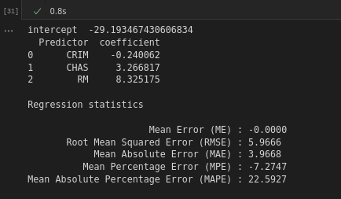

c.
Using the estimated regression model, what median house price is predicted for a tract in the Boston area that does not bound the Charles River, has a crime rate of 0.1, and where the average number of rooms per house is 6?

# c.
housing_lm_pred = housing_lm.predict([[0, 0.1, 6]])
print(housing_lm_pred)

# Since no other samples exist for this data point, no residual error is able to be obtained.

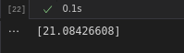

d.
Reduce the number of predictors:
i. Which predictors are likely to be measuring the same thing among the 13 predictors? Discuss the relationships among INDUS, NOX, and TAX.

# i.
corr = housing_df.corr()
fig, ax = plt.subplots()
fig.set_size_inches(11, 7)
sns.heatmap(corr, annot=True, fmt=".1f", cmap="RdBu", center=0, ax=ax)

# Relationship between INDUS, RAD, and TAX
RAD and TAX are strongly correlated, measuring at 0.9.
INDUS and RAD are positively correlated, measuring at 0.6.
INDUS and TAX is a bit more positively correlated, measuring at 0.7.
All three of these indicate that they would be measuring the same thing.

ii. Compute the correlation table for the 12 numerical predictors and search for highly correlated pairs. These have potential redundancy and can cause multi-collinearity. Choose which ones to remove based on this table.

sns.heatmap(corr, annot=True, fmt=".1f", cmap="RdBu", center=0, ax=ax)

# Highly Correlated Pairs
ZN and DIS
RAD and TAX
PTRATIO and RAD
PTRATIO and TAX

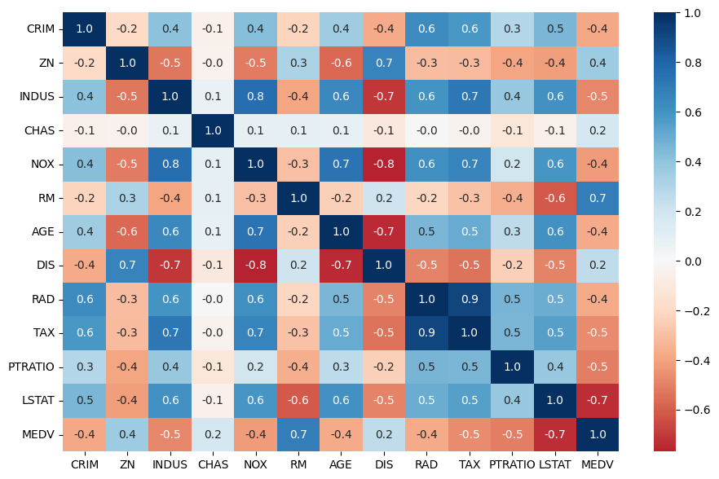

iii. Use three subset selection algorithms: backward, forward, and stepwise) to reduce the remaining predictors. Compute the validation performance for each of the three selected models. Compare RMSE, MAPE, and mean error, as well as histograms of the errors. Finally, describe the best model.

# d.
# iii.
def train_model(variables):
if len(variables) == 0:
return None
model = LinearRegression()
model.fit(train_X[variables], train_y)
return model

def score_model(model, variables):
if len(variables) == 0:
return AIC_score(train_y, [train_y.mean()] * len(train_y), model, df=1)
return AIC_score(train_y, model.predict(train_X[variables]), model)

print("Backward")
best_back_model, best_back_variables = backward_elimination(train_X.columns, train_model, score_model, verbose=True)
print(best_back_variables)
regressionSummary(train_y, best_back_model.predict(train_X))
print()

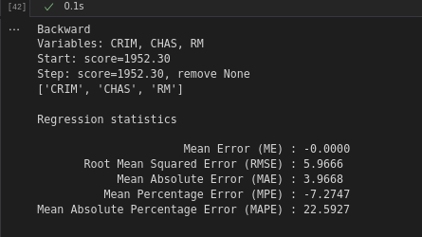

print("Forward")
best_forw_model, best_forw_variables = forward_selection(train_X.columns, train_model, score_model, verbose=True)
print(best_forw_variables)
forw_train_X = train_X.loc[:,['RM','CRIM','CHAS']]
regressionSummary(train_y, best_forw_model.predict(forw_train_X))

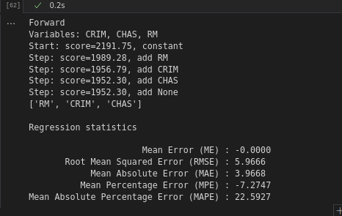

# d iii. continued
print("Stepwise")
best_step_model, best_step_variables = forward_selection(train_X.columns, train_model, score_model, verbose=True)
print(best_step_variables)
step_train_X = train_X.loc[:,['RM','CRIM','CHAS']]
regressionSummary(train_y, best_step_model.predict(step_train_X))
test=regressionSummary(train_y, best_step_model.predict(step_train_X))

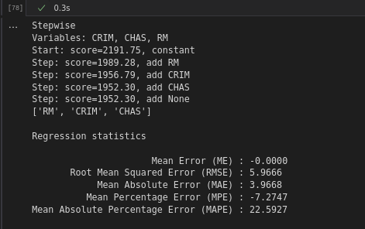

# d iii model
print("LASSO")
lasso = Lasso(alpha=1)
lasso.fit(train_X, train_y)
regressionSummary(valid_y, lasso.predict(valid_X))
print("\n")

print("LASSO CV")
lasso_cv = LassoCV(cv=5)
lasso_cv.fit(train_X, train_y)
regressionSummary(valid_y, lasso_cv.predict(valid_X))
print('Lasso-CV chosen regularization: ', lasso_cv.alpha_)
print(lasso_cv.coef_)
print("\n")

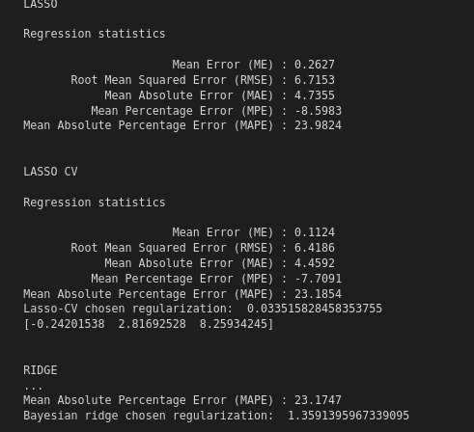

print("RIDGE")
ridge = Ridge(alpha=1)
ridge.fit(train_X, train_y)
regressionSummary(valid_y, ridge.predict(valid_X))
print("\n")

print("BAYESIAN RIDGE")
bayesianRidge = BayesianRidge()
bayesianRidge.fit(train_X, train_y)
regressionSummary(valid_y, bayesianRidge.predict(valid_X))
print('Bayesian ridge chosen regularization: ', bayesianRidge.lambda_ / bayesianRidge.alpha_)
print("\n")

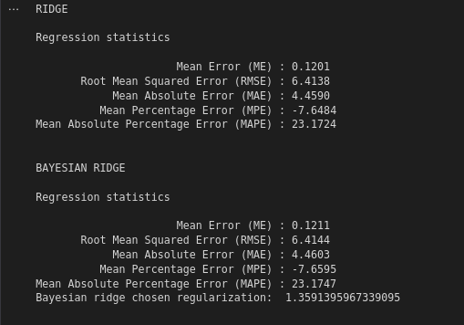

# Best model
Bayesian Ridge: Lowest MAPE
Ridge: Lowest RMSE, lowest MAE

Ridge or Bayesian Ridge should be used. Further parameter tuning can assist in selection which of the two models to use.

