QM-7063 Data Mining
Professor: Dr. Abdulrashid
Learning Practice 2 – Noah L. Schrick

4.1 Breakfast Cereals.
Use the data for the breakfast cereals example in Section 4.8 to explore and summarize the data as follows:
a. Which variables are quantitative/numerical? Which are ordinal? Which are nominal?

Numerical Ordinal Nominal
Calories Index Name
Sodium Shelf MFR
Protein Rating Type
Fat Vitamins
Fiber
Carbo
Sugars
Potass
Weight
Cups
b. Compute the mean, median, min, max, and standard deviation for each of the quantitative variables. This can be done using pandas as shown in Table 4.3.

## Compute mean, median, min, max, and standard deviation for quantitative variables
quan_df = cereals_df[["calories", "sodium", "protein", "fat", "fiber", "carbo", "sugars", "potass", "weight", "cups"]]
pd.DataFrame({'mean': quan_df.mean(),
'median': quan_df.median(),
'min': quan_df.min(),
'max': quan_df.max(),
'sd': quan_df.std()
})

mean median min max sd
calories 106.883117 110.00 50.00 160.0 19.484119
sodium 159.675325 180.00 0.00 320.0 83.832295
protein 2.545455 3.00 1.00 6.0 1.094790
fat 1.012987 1.00 0.00 5.0 1.006473
fiber 2.151948 2.00 0.00 14.0 2.383364
carbo 14.802632 14.50 5.00 23.0 3.907326
sugars 7.026316 7.00 0.00 15.0 4.378656
potass 98.666667 90.00 15.00 330.0 70.410636
weight 1.029610 1.00 0.50 1.5 0.150477
cups 0.821039 0.75 0.25 1.5 0.232716

c. Plot a histogram for each of the quantitative variables. Based on the histograms and summary statistics, answer the following questions:

## Histogram for each of the quant vars
quant_vars = ["calories", "sodium", "protein", "fat", "fiber", "carbo", "sugars", "potass", "weight", "cups"]
rowcounter = 0
colcounter = 0

# 2 columns
cols = 2
rows = len(quant_vars) // cols
if (len(quant_vars) % cols != 0):
rows += 1

fig, axes = plt.subplots(nrows=int(rows), ncols=int(cols))

for var in quant_vars:
ax = cereals_df[var].hist(ax=axes[int(rowcounter)][int(colcounter)], figsize=(10,7))
ax.set_xlabel(var); ax.set_ylabel('Count') # set x and y-axis label

if (rowcounter == (rows-1)):
rowcounter = 0
colcounter += 1
else:
rowcounter += 1

plt.tight_layout()
plt.show()
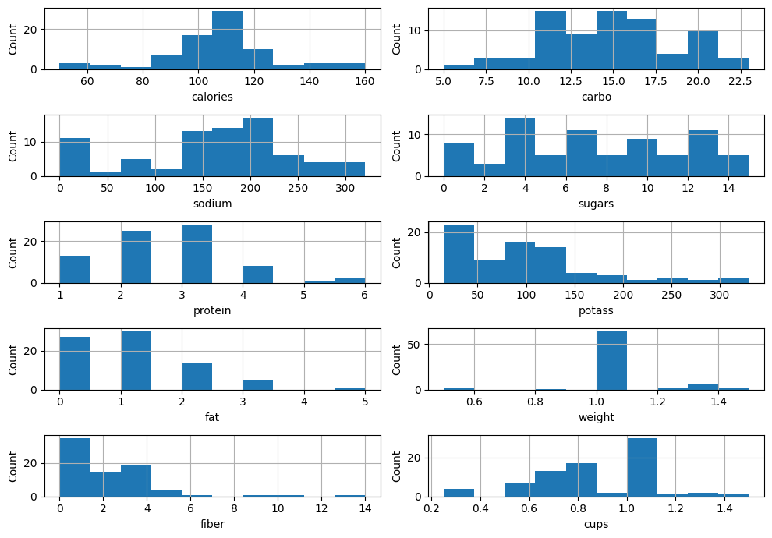
i. Which variables have the largest variability?
Sugars, Carbo, Sodium, Protein

ii. Which variables seem skewed?
Fiber, Potass

iii. Are there any values that seem extreme?
1.0 - Weight

d. Plot a side-by-side boxplot comparing the calories in hot vs. cold cereals. What does this plot show us?
e. Plot a side-by-side boxplot of consumer rating as a function of the shelf height. If we were to predict consumer rating from shelf height, does it appear that we need to keep all three categories of shelf height?
f. Compute the correlation table for the quantitative variable (method corr()). In addition, generate a matrix plot for these variables (see Table 3.4 on how to do this using the seaborn library).
i. Which pair of variables is most strongly correlated?

ii. How can we reduce the number of variables based on these correlations?

iii. How would the correlations change if we normalized the data first?
g. Consider the first PC of the analysis of the 13 numerical variables in Table 4.12. Describe briefly what this PC represents

