CS-7863 Homework #4 Noah Schrick
Degree Distribution

For this homework, the network used was igraph’s yeast network. Four different approaches for finding the degree distribution were used:

1. Trying different, arbitrary alpha values and seeing what looked best
2. Using a Poisson distribution based on the average degree
3. Using a linear modeling approach with a least-squares fit
4. Using a Max-Log-Likelihood fit approach

The histogram of the yeast network is as follows:
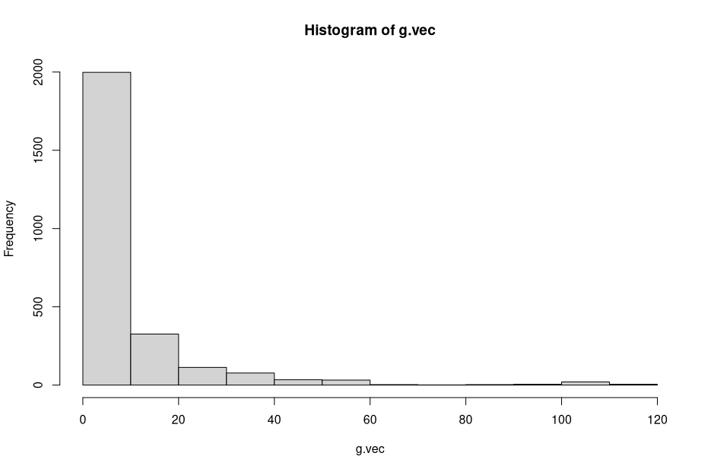
The histogram that shows all four fits is as follows:
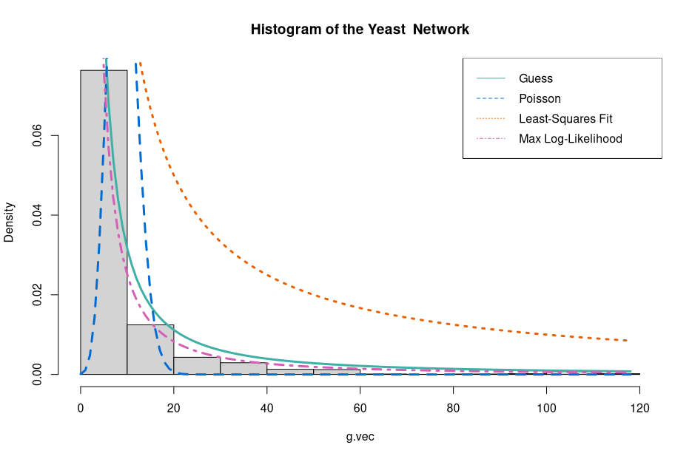
The values for alpha for the four approaches are as follows, respectively:
1.) 1.5
2.) (Average degree): 9.059
3.) 1
4.) 1.6

The Poisson distribution was not well-fitted due to the skew in degree. The top 6 degrees in the network are 118, 115, 114, 113, 113, and 108, whereas the bottom 6 are 1, 1, 1, 1, 1, and 1. The standard deviation is 14.967.

The least-squares fit was also not well-fitted due to the tail which skews the result.

The maximum-log-likelihood approach was close to the guessing approach with an alpha of 1.6 vs 1.5.

The histogram appears to follow a power-law distribution, though it is not classifiable as a scale-free network since the alpha value does not fit within the 2-3 range.

