CS-7863 Homework #3 Noah Schrick

Laplace Spectral Clustering
Karate:
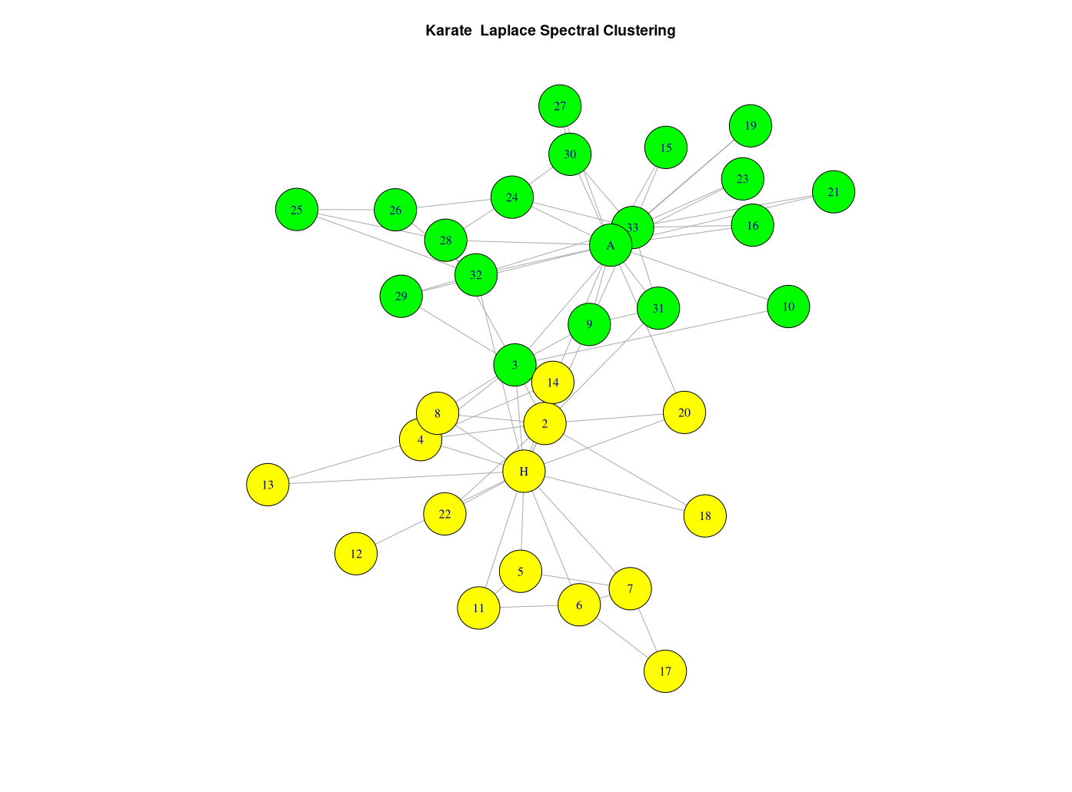

Yeast:
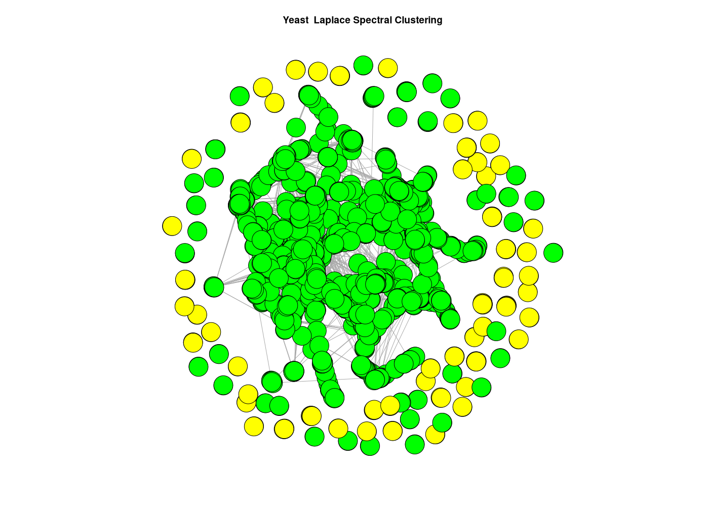

Newman Modularity
Karate:
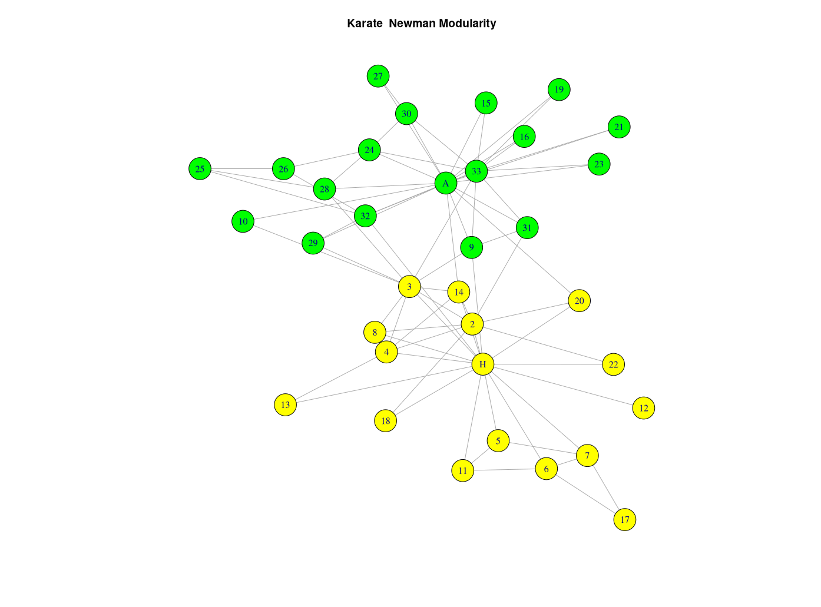

Slight difference: “3” is now part of the yellow community, when it was part of the green community with Laplace spectral clustering. Otherwise, community structures are identical.

Yeast:
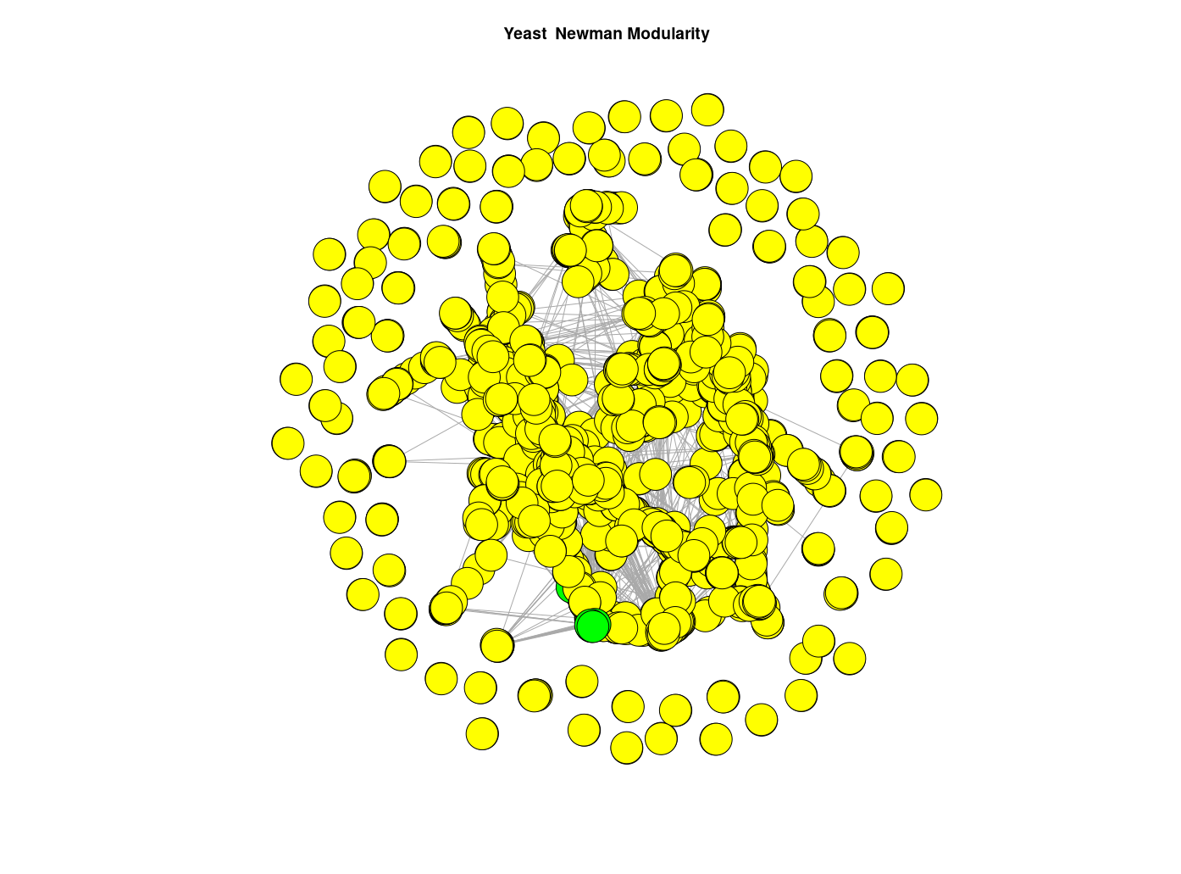

Very large differences with the yeast network. With Laplace spectral clustering, there was one large community that included all of the “central” nodes and some fringe nodes, with a second community that contained only fringe nodes. With this approach, almost every node is part of the same community. However, there are some central nodes that are part of a separate sub-community.

Recursive Newman Modularity (fastgreedy)
Karate:

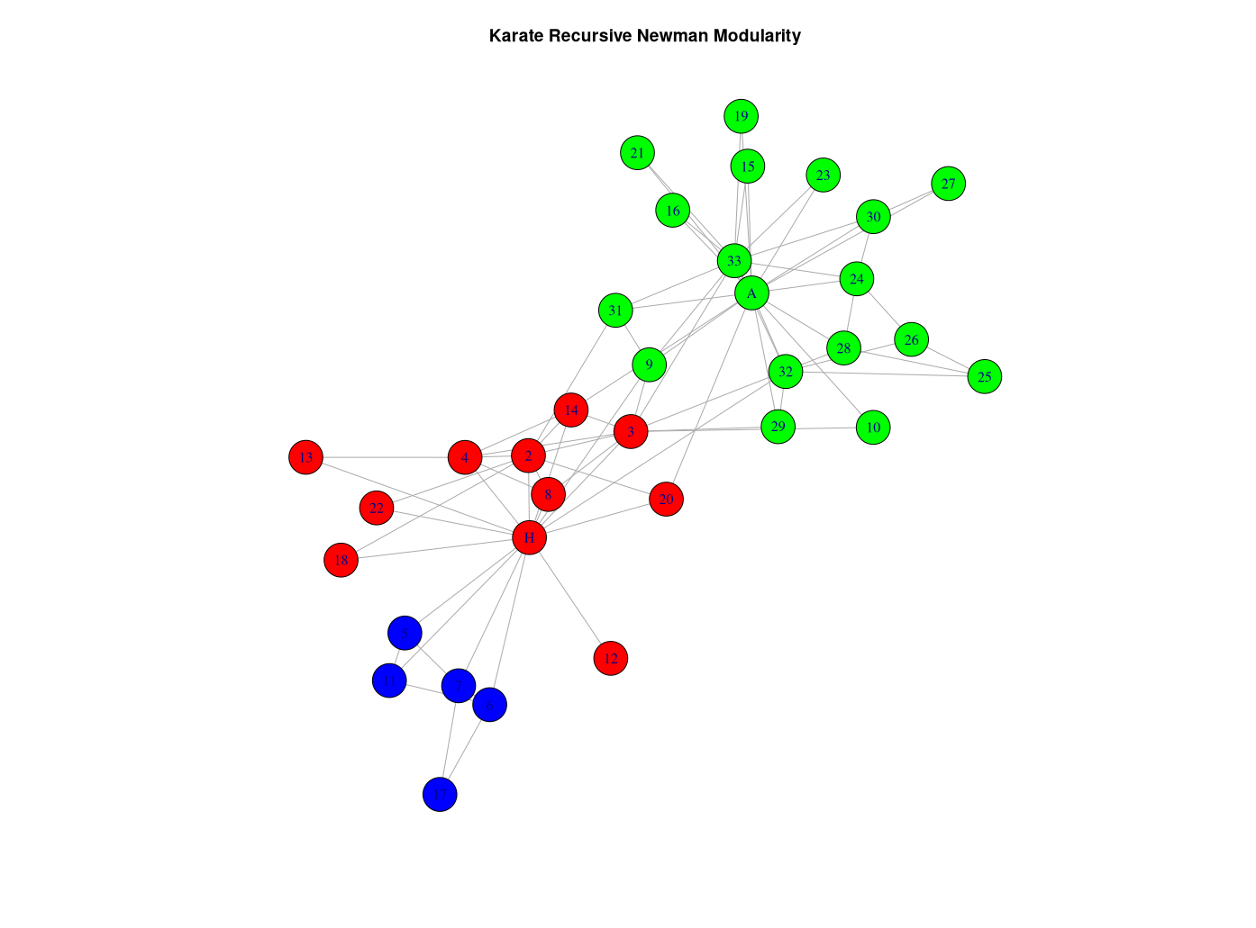

When using the recursive approach that tries to fine-tune the community detection, 3 communities are detected. One of the communities is a sub-community of the larger two factions, and includes 5 of the “fringe” nodes that have close ties.

Yeast:
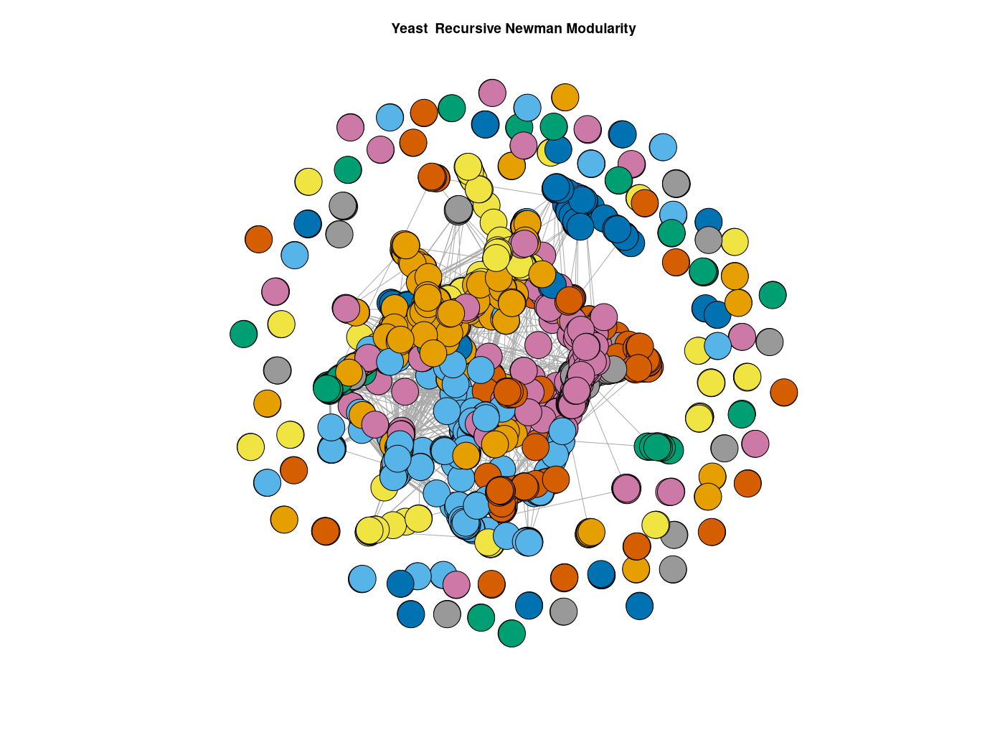
The yeast network has 2617 nodes, and using the recursive approach, 127 communities were detected. The largest community contains 744 nodes (28.43% of the network). The majority of the “central” nodes fell into relatively few communities, while the majority of the communities consist of fringe nodes.

TOM and Dynamic Tree Cut
Karate:

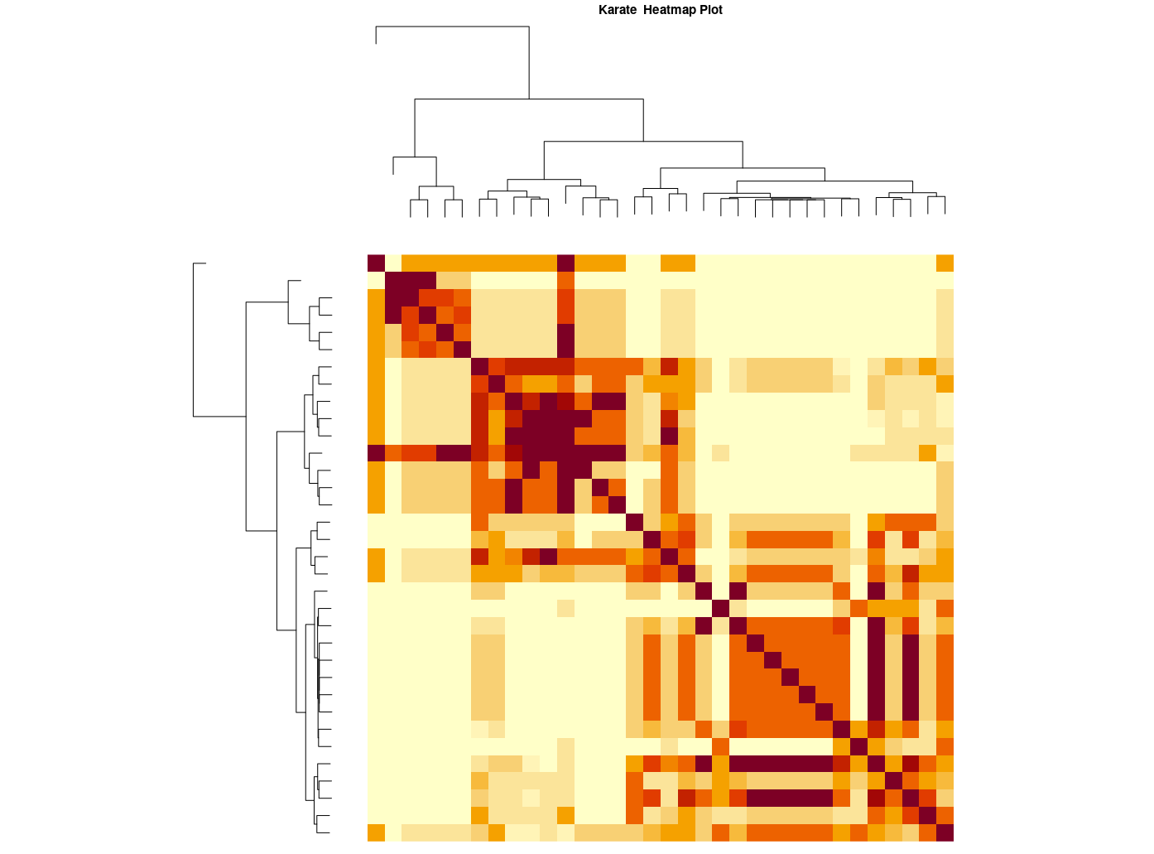

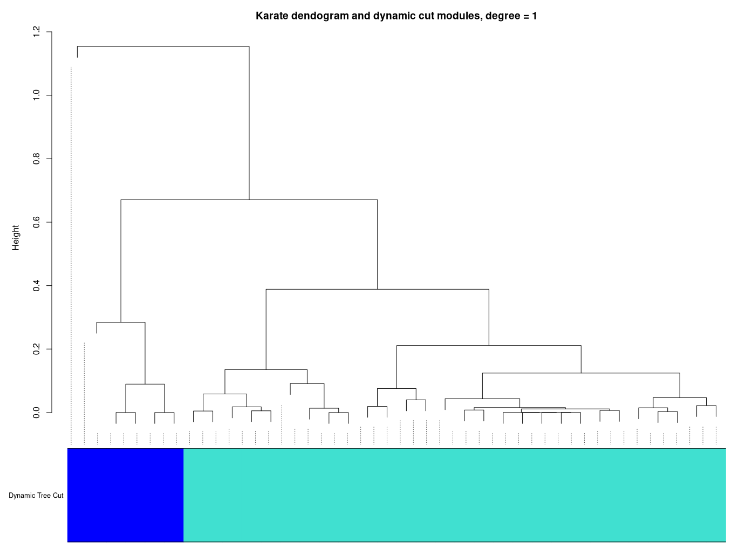

Yeast:
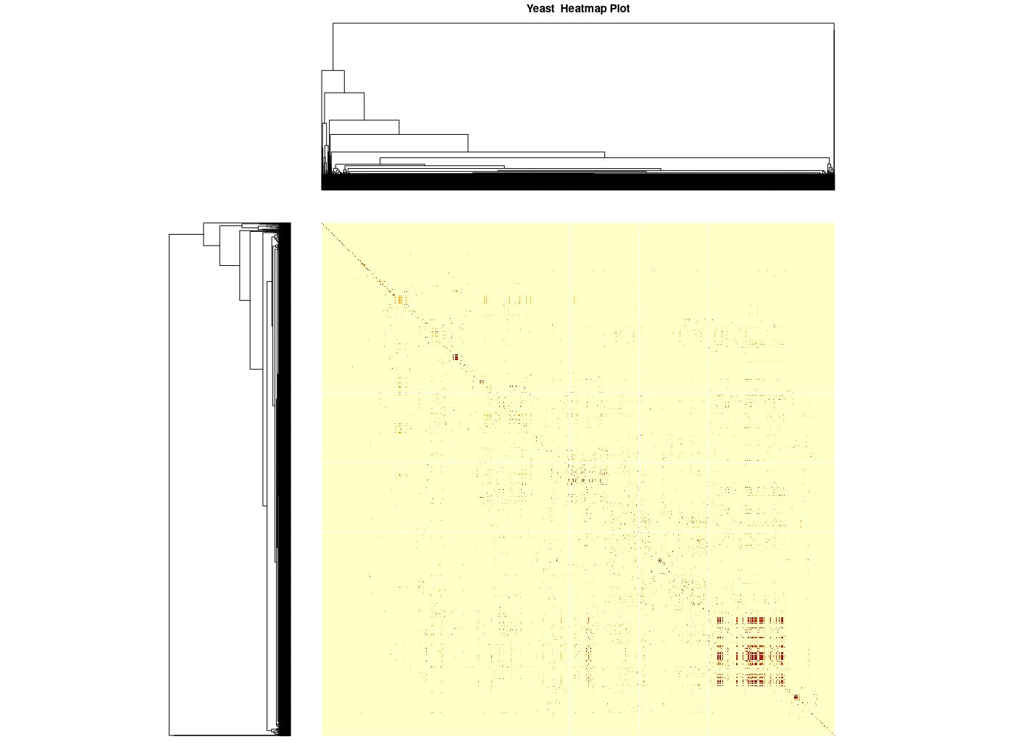

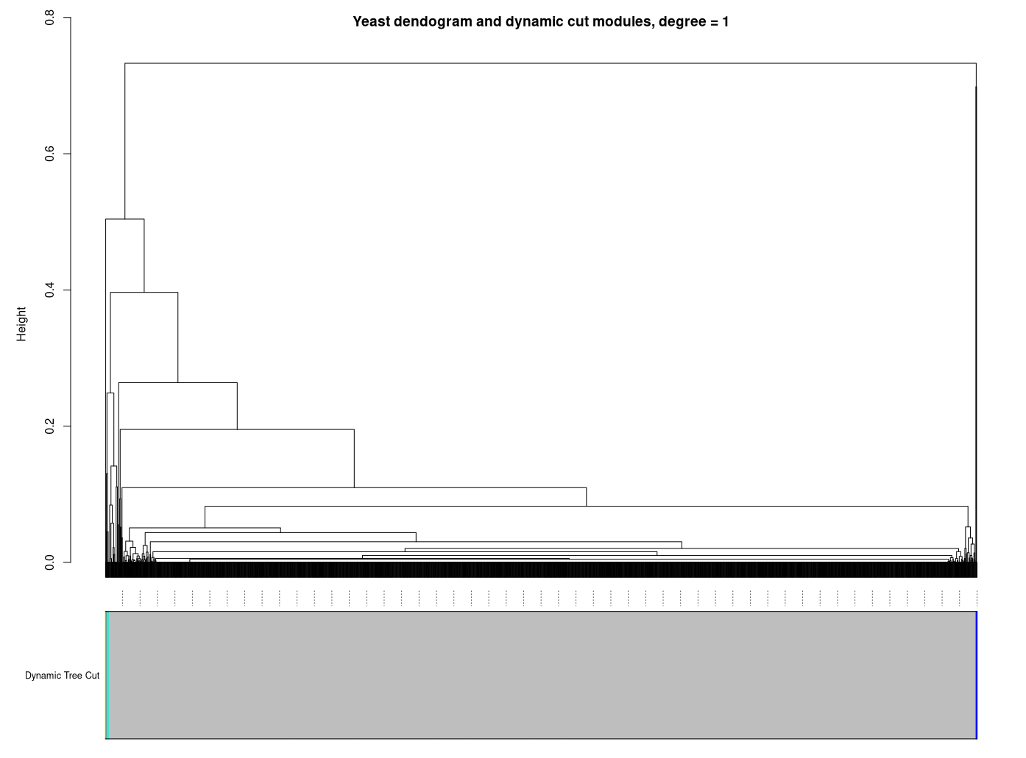

Multiple colors present: Blue=3, Brown=2, Green=2, Grey=2600, Turquoise=8, Yellow=2

UMAP
Karate:
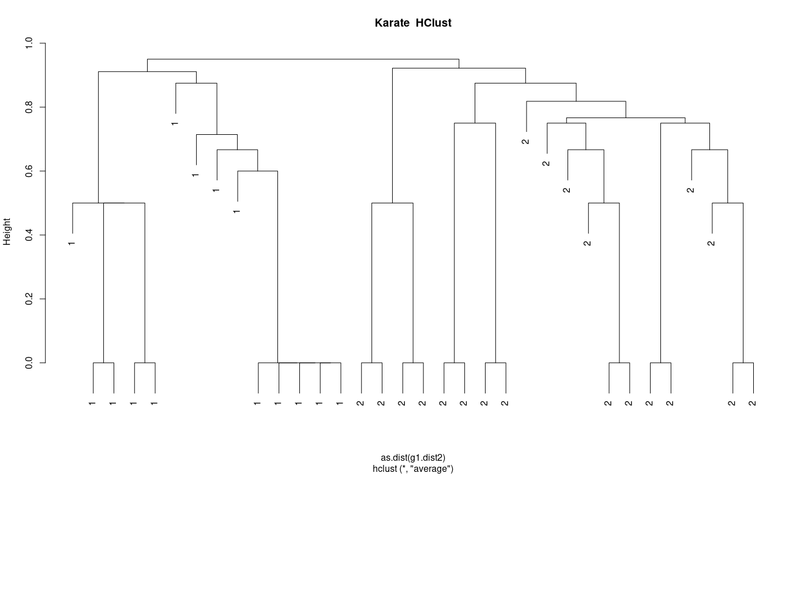

Yeast:



