CS-7863: Scientific and Statistical Computing
Homework #2
Noah L. Schrick – 1492657

1.)

## Part 1: Bisection
findZeroBisect <- function(func, xl, xr, tol, maxsteps=1e6){
steps <- 0
if (func(xl) * func(xr) >= 0){
stop("Bad interval: try again with different endpoints")
}

repeat{
xm <- (xl + xr)/2
if(abs(func(xm)) < tol || steps >= maxsteps){
break
}

ifelse(func(xl) * func(xm) > 0, xl<-xm, xr<-xm)
steps <- steps + 1
}
return(c(xm, func(xm), steps))
}

Note: The plotting code shown in part 1a is used for all subsequent parts and sub-parts. The code is not pasted in this document again for sake of brevity, but it is present in the attached R script. For questions that involve multiple roots, extra lines for geom_vline were added.

1.a)
# Solve 1a
fun.a <- function(x) {x^2-2}
fun.a.string <- "x^2-2=0"
sqrt2.estimate <- findZeroBisect(fun.a,1,2,1e-6)

# Plot 1a
if (!require("ggplot2")) install.packages("ggplot2")
library(ggplot2)
ggplot(data.frame(x=seq(1,2,.1)), aes(x)) +
stat_function(fun=fun.a, aes(col=fun.string)) +
geom_hline(aes(yintercept=0, col = "y=0"), show.legend=TRUE)+
geom_vline(aes(xintercept=sqrt2.estimate[1],
col = "bisection estimate"), show.legend=TRUE)+
ggtitle("Zero Function") +
xlab("x") + ylab("Zero Function") +
theme(text = element_text(size=20), plot.title = element_text(hjust = 0.5))

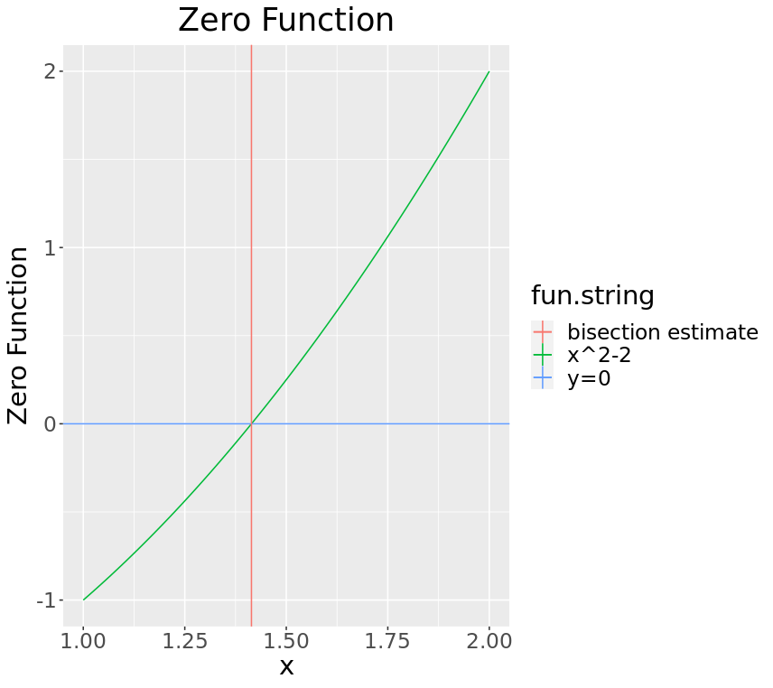

> sqrt2.estimate
[1] 1.414214e+00 2.687177e-07 2.000000e+01

1.b)
fun.b <- function(x) {-3+x+2*exp(-x)}
fun.b.string <- "-3+x+2*exp(-x)=0"
fun.b.estimate.left <- findZeroBisect(fun.b,-2.5,0,1e-6)
fun.b.estimate.right <- findZeroBisect(fun.b,1,4,1e-6)

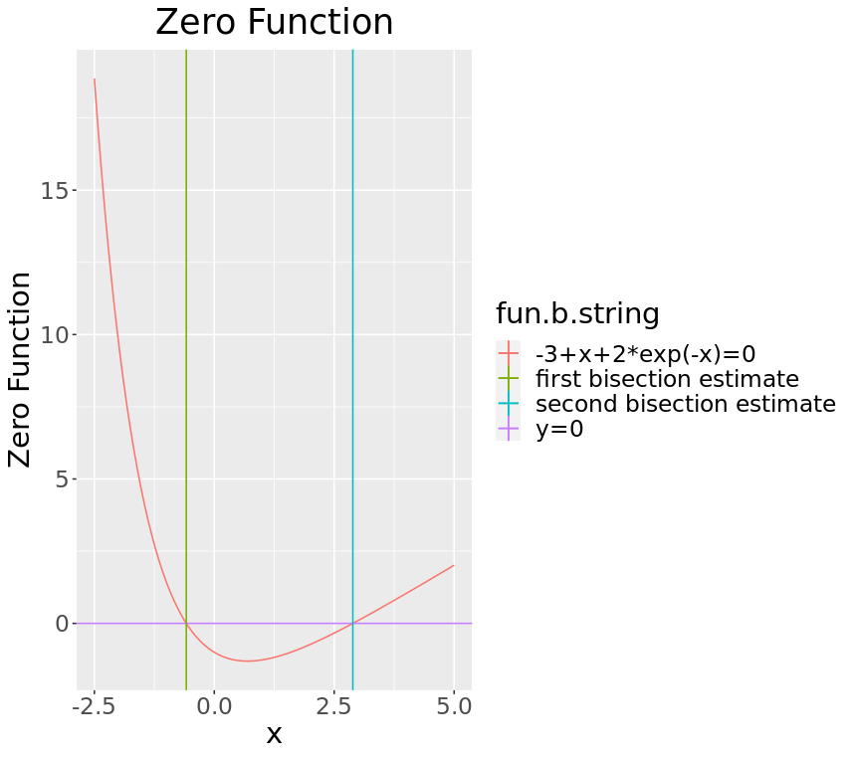

> fun.b.estimate.left
[1] -5.830741e-01 5.600836e-07 1.900000e+01
> fun.b.estimate.right
[1] 2.888704e+00 8.386990e-07 1.800000e+01

1.c)
fun.c <- function(x) {x^3-sin(x)^2}
fun.c.string <- "x^3-sin(x)^2=0"
fun.c.estimate <- findZeroBisect(fun.c,0.5,1,1e-6)

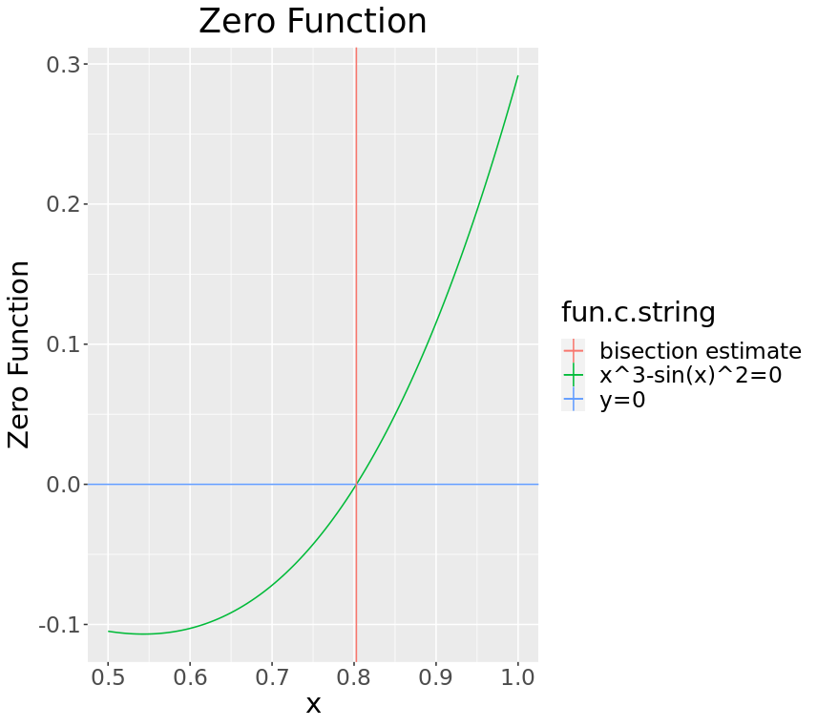

> fun.c.estimate
[1] 8.02803e-01 -6.46562e-07 1.50000e+01

2.a)
## Part 2: Relaxation Method
findZeroRelax <- function(g, x.guess, tol=1e-6, maxsteps=1e6){
steps <- 0
x.old <- x.guess
isConverged <- FALSE
while (!isConverged){
x.new <- g(x.old)
if(steps >= maxsteps || (abs(x.new-x.old)<tol)){
isConverged <- TRUE
}
else{
x.old <- x.new
}
steps <- steps + 1
}
return(c(x.new, g(x.new), steps))
}

2.b)
fun.2b <- function(x) {2-exp(-x)}
fun.2b.fx <- function(x) {x-2+exp(-x)}
fun.2b.string <- "x-2+exp(-x)"
fun.2b.estimate <- findZeroRelax(fun.2b,0)
# Find the other root with bisection
fun.2b.bisect <- findZeroBisect(fun.2b,-2,0,1e-6)

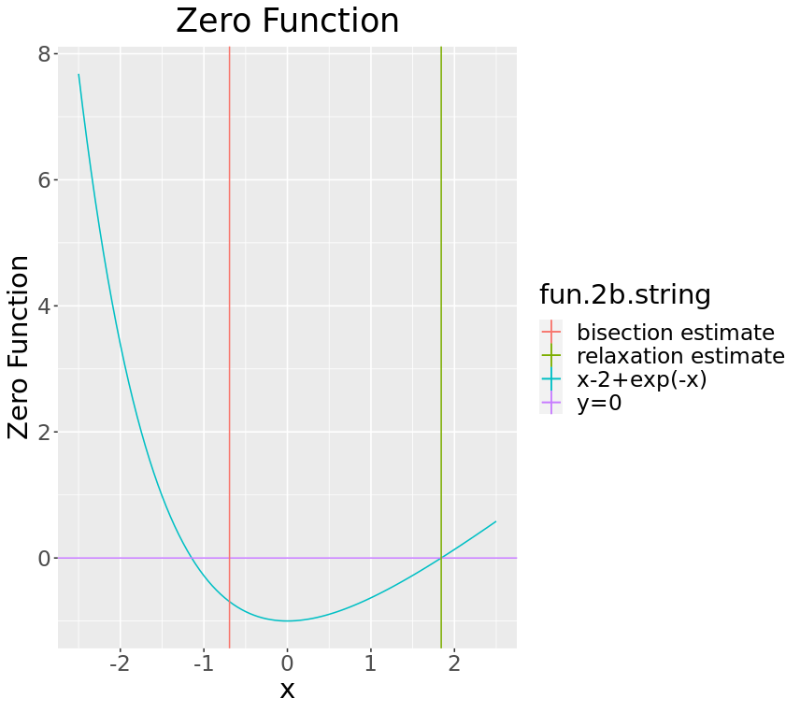

> fun.2b.estimate
[1] 1.841406 1.841406 10.000000
> fun.2b.bisect
[1] -6.931477e-01 -9.574839e-07 1.900000e+01

2.c)
# Solve 2c
fun.2c <- function(x) {3-2*exp(-x)}
fun.2c.fx <- function(x) {x+2*exp(-x)-3}
fun.2c.string <- "x+2*exp(-x)-3"
fun.2c.estimate <- findZeroRelax(fun.2c,-.5)
# Find the other root with bisection
fun.2c.bisect <- findZeroBisect(fun.2c,-1,0,1e-6)

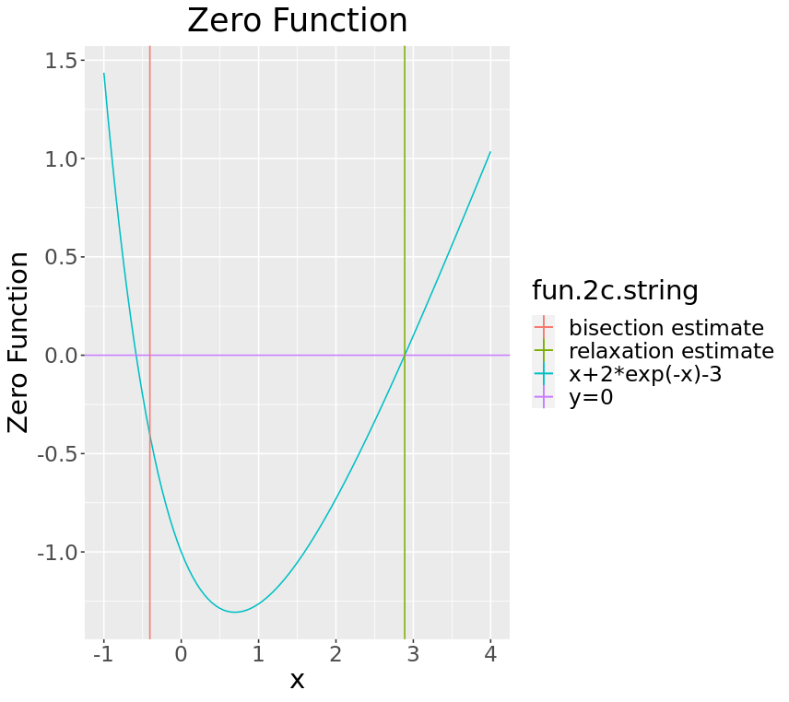
> fun.2c.estimate
[1] 2.888703 2.888703 11.000000
> fun.2c.bisect
[1] -4.054651e-01 -5.378830e-08 1.900000e+01

3.a)
fun.3a.fx <- function(x) {5*exp(-x)+x-5}
fun.3a <- function(x) {5-5*exp(-x)}
fun.3a.string <- "5*exp(-x)+x-5"
fun.3a.estimate <- findZeroRelax(fun.3a,4)

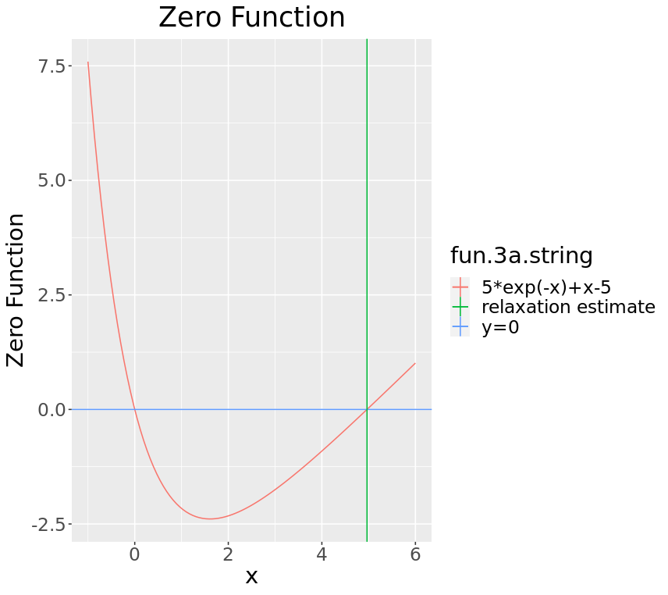

> fun.3a.estimate
[1] 4.965114 4.965114 6.000000

3.b)
peak.wavelength <- (1239.84)/((8.61733e-5)*(fun.3a.estimate[1])*(5778))
> peak.wavelength
[1] 501.5176
Green

3.c)
# define I_Planck function
I_Planck <- function(wavelength, temp){
intensity = ((8*pi*1.23984e3)/(wavelength^5))/(exp(1.23984e3/(wavelength*temp*8.61733e-5))-1)
return(intensity)
}

lam.vec <- seq(100,2000,len=70)
plot(lam.vec, I_Planck(lam.vec,5778), type = "l", lty = 1,
xlab="wavelength (nm)", ylab="Energy Density",
main="Wavelength peaks for different T (K)")
grid(NULL,NULL)
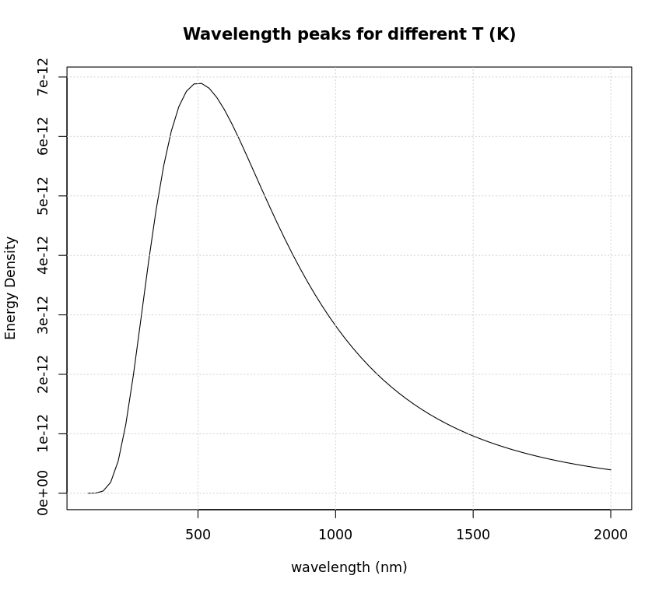

4.)

# Solve
implicitFF <- function(Re,ed,x.guess,tol=1e-6){
if (Re<2000){
f0 <- 16/Re
} else {
fun.4 <- function(x) {(-16*log10((ed/3.7)+(1.255/(Re*sqrt(x)))))^-2}
fun.4.string <- "(-16*log10((ed/3.7)+(1.255/(Re*sqrt(x)))))^-2"
fun.4.estimate <- findZeroRelax(fun.4,x.guess)
f0 <- fun.4.estimate[1]
}

# Plot
func.plot <- ggplot(data.frame(x=seq(0,2,.1)), aes(x)) +
stat_function(fun=fun.4, aes(col=fun.4.string)) +
geom_hline(aes(yintercept=0, col = "y=0"), show.legend=TRUE)+
geom_vline(aes(xintercept=fun.4.estimate[1],
col = "relaxation estimate"), show.legend=TRUE)+
ggtitle("Zero Function") +
xlab("x") + ylab("Zero Function") +
theme(text = element_text(size=20), plot.title = element_text(hjust = 0.5))
print(func.plot)
return(f0)
}

4.a)
fa.estimate <- implicitFF(7000, 0.0001, 0.1)

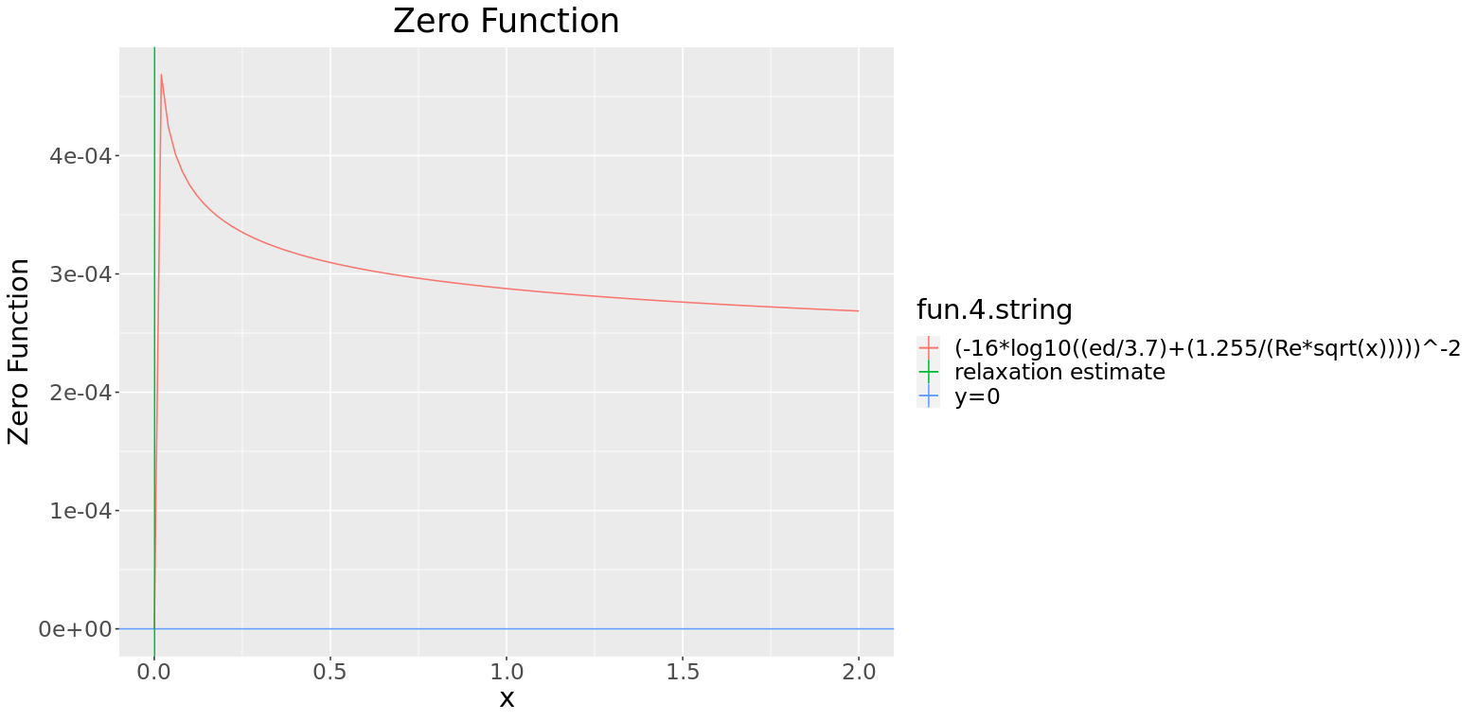

> fa.estimate
[1] 0.0008082328

4.b)
fb.estimate <- implicitFF(8000, 0.0001, 0)
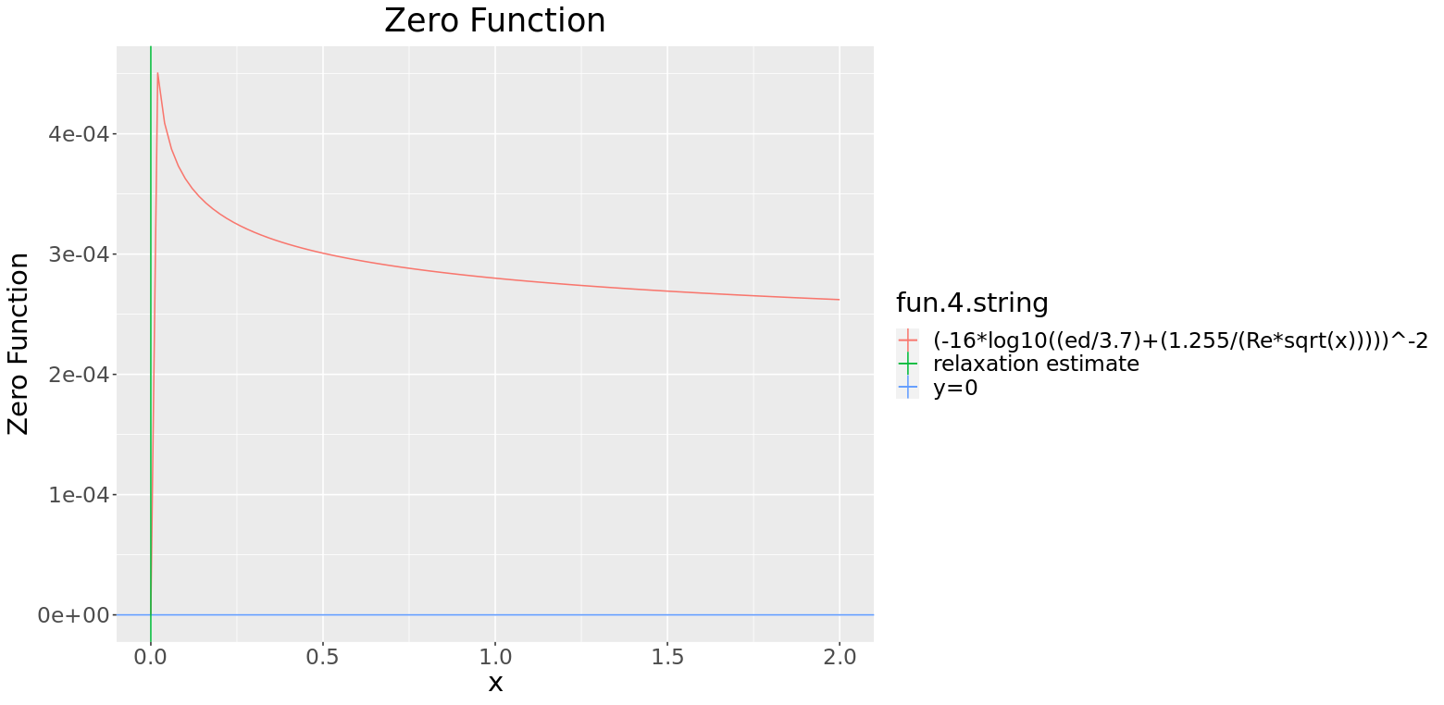

> fb.estimate
[1] 0

4.c)
fc.estimate <- implicitFF(9000, 0.0001, 0)
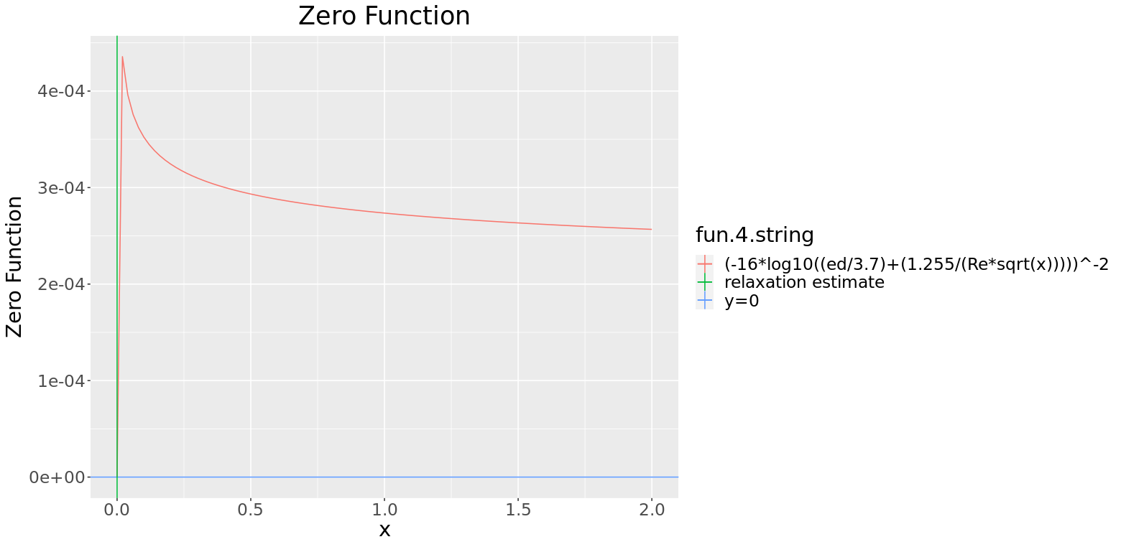

> fc.estimate
[1] 0

5.a)
# a:
g <- 10000
d <- 2
l <- 0

func.five <- function(u){
(-10000/(2*pi)) +
(u/2) *
sqrt((u^2)-((d+2*l)^2)/4) +
(((d+2*l)^2)/16) *
log((u-sqrt((u^2)-((d+2*l)^2)/4))/(u+sqrt((u^2)-((d+2*l)^2)/4)))
}

func.five.string <- "function"
func.five.estimate <- findZeroBisect(func.five,50,75,1e-6)

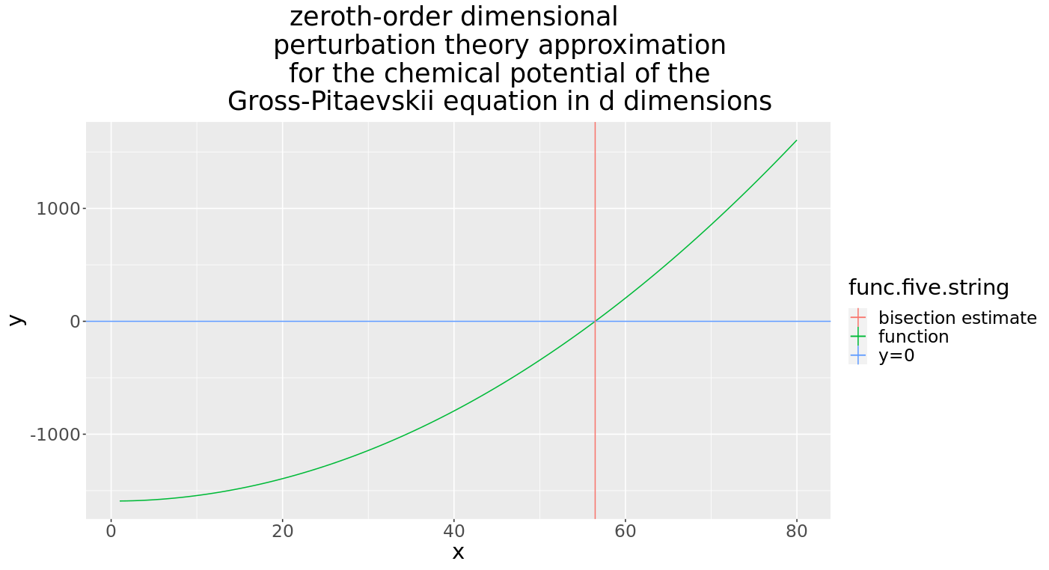

> func.five.estimate
[1] 5.646526e+01 2.054011e-07 2.800000e+01

5.b)
# b:
g <- 10000
d <- 2
l <- 1

func.five <- function(u){
(-10000/(2*pi)) +
(u/2) *
sqrt((u^2)-((d+2*l)^2)/4) +
(((d+2*l)^2)/16) *
log((u-sqrt((u^2)-((d+2*l)^2)/4))/(u+sqrt((u^2)-((d+2*l)^2)/4)))
}

func.five.string <- "function"
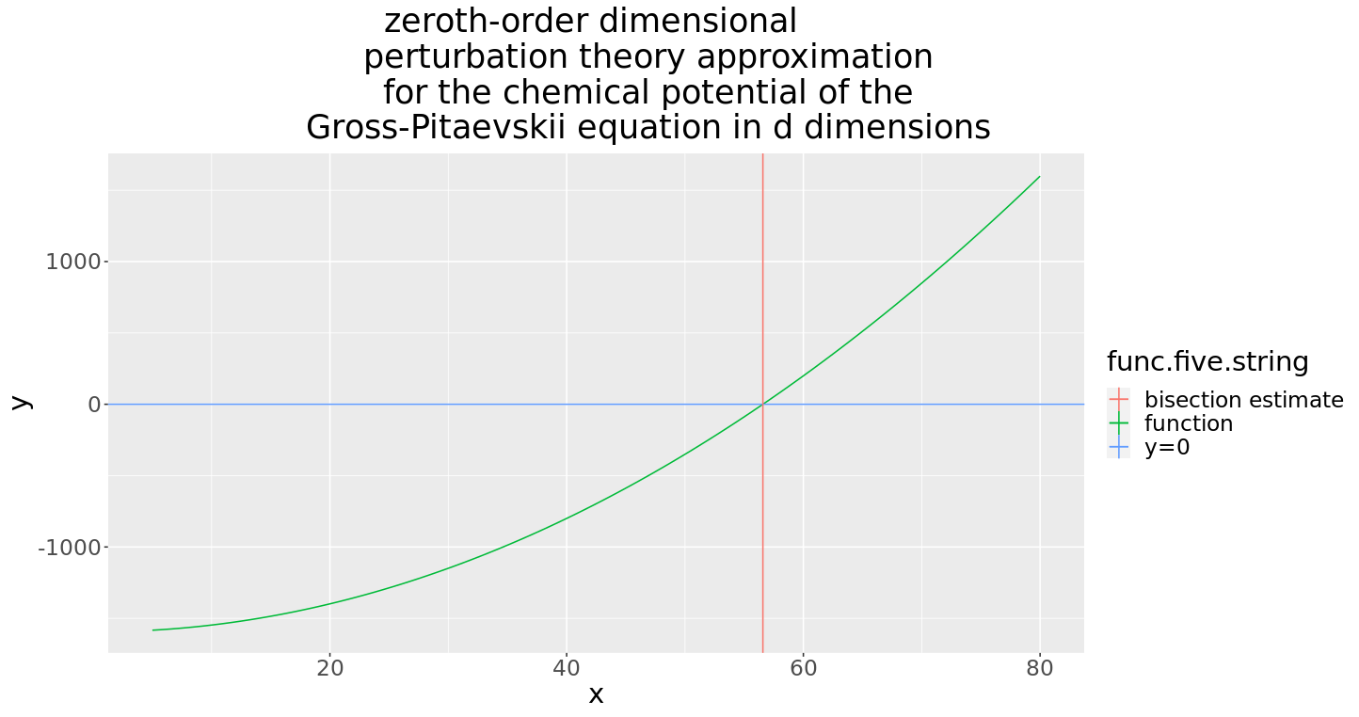
func.five.estimate <- findZeroBisect(func.five,50,75,1e-6)

> func.five.estimate
[1] 5.657951e+01 -4.968289e-07 2.800000e+01

