CS-7863: Scientific and Statistical Computing
Homework #1
Noah L. Schrick – 1492657

1.a)

## Part A: compute binding energy
computeBindingEnergy <- function(A, Z){
if (A %% 2 == 1) {
spin <- 0
}else if (A %% 2 == 0 && Z %% 2 == 0){
spin <- 12
}
else {
spin <- -12
}

return((15.67*A)-
(17.23*(A^(2/3)))-
((0.75)*((Z^2)/(A^(1/3))))-
((93.2)*(((A-(2*Z))^2)/A))+
(spin/(A^(1/2))))
}

1.b)

## Part B: compute Z=28 and A=58
# Nickel
bind.energy <- computeBindingEnergy(58,28)
cat(round(bind.energy,digits=2),"MeV")

493.94 MeV

1.c)

## Part C: table with two columns: nucleons and binding energy per nucleon
Z=6 # Carbon
carbon_df <- data.frame(nrow=2*Z, ncol=2)
for (i in seq(Z, 3*Z)){
# +1 since R indexes at 1
carbon_df[i-Z+1,] <- rbind(i, computeBindingEnergy(i, Z)/i)
}
rownames(carbon_df) <- NULL
colnames(carbon_df) <- c("A", "B/A")
print(carbon_df, row.names=FALSE)
# Get max binding energy row
print(carbon_df[which.max(carbon_df$"B/A"),], row.names=FALSE)

plot(carbon_df$A, carbon_df$"B/A", xlab="Number of Nucleons",
ylab="Binding Energy [MeV]",
main="Number of Nucleons on Binding Energy for Carbon")

A B/A
6 -88.6719833
7 -42.9044922
8 -17.4021699
9 -4.4111252
10 3.0707868
11 6.0487081
12 7.4500014
13 6.9074722
14 6.0478948
15 4.2257131
16 2.5250851
17 0.2890953
18 -1.6752533

> print(carbon_df[which.max(carbon_df$"B/A"),], row.names=FALSE)
A B/A
12 7.450001

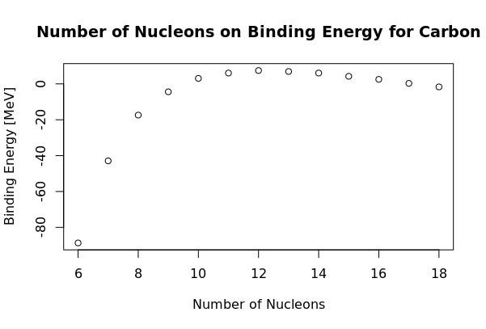

1.d)

## Part D: find the value of A that gives the maximum binding energy
computeMaxBind <- function(Z){
maxBind <- -Inf
A.maxBind <- -Inf
for (i in seq(Z, 3*Z)){
bindE <- computeBindingEnergy(i, Z)/i
if (bindE > maxBind){
maxBind <- bindE
A.maxBind <- i
}
}
return(c(A.maxBind, maxBind))
}

1.e)
bounds <- 100
binding_df <- data.frame(nrow=bounds, ncol=2)
for (i in seq(1, bounds)){
binding_df[i,] <- c(i, computeMaxBind(i)[2])
}

plot(binding_df, xlab="Atomic Number", ylab="B/A [MeV]", type="o",
main="Maximum Binding Energy for Most Stable Isotopes of Each Atom")

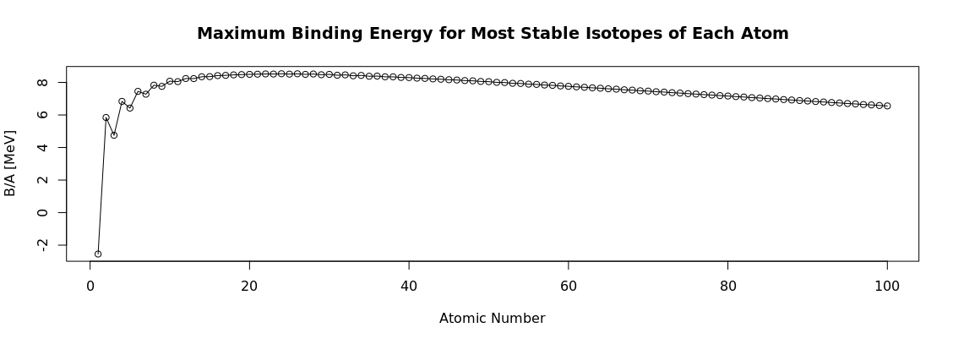

# Z with largest binding energy
print(binding_df[which.max(unlist(binding_df[2])),], row.names=FALSE)

nrow ncol
24 8.532623

