Epidemiology Modeling for Compliance Graph Analysis

Noah L. Schrick
05 May 2023

Introduction

Compartment | Description | Contextualization to Compliance Graphs
S | Susceptible | All other nodes.
E | Exposed | Nodes flagged as at risk of compliance violation by an IDS, timeframe trigger, or other.
I | Infected | Nodes that are in violation.
R | Recovered | Nodes that were infected and were capable of automatic correction (certificate renewal, scheduled maintenance, or other).
D | Deceased | Nodes removed from the network through quarantine, DMZ, legacy removal, or other.

Parameter | Description | Contextualization to Compliance Graphs
β | Infection Rate | Probability of nodes falling out of compliance.
δ | Incubation Period | Once a node is at risk of falling out of compliance, how long it takes to actually violate a mandate or regulation.
Ɣ_{R} | Recovery Rate | Probability of a system to correct its violation status.
Ɣ_{D} | Death Rate | Probability of removal for a system in violation.
μ | Fatality Ratio | Natural rate at which any node may be removed from the network.
ϵ | Infected Import Rate | Systems that are already in violation; systems that do not fall out of compliance, but are already violating a mandate.
ω | Waning Immunity Rate | After a system recovers, how long for it to be available for violation.

Methodology
In order to apply epidemiology modeling to compliance graph, a few considerations were necessary. The compliance graphs are represented through a Graphviz dotfile, and must be imported as a graph object. This graph object must be iterated through, and must be used to derive the epidemiology model parameters and compartments. These parameters and compartments will then be used for an ODE solver. These processes are described in the following subsections.
Model

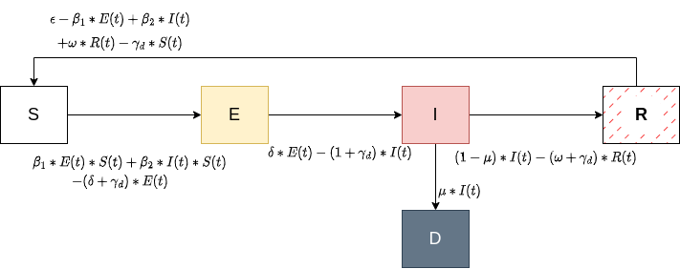

Parameter and Compartments through Python
ODE Solver through R
Incorporating Network Weights

Results and Analysis
Unweighted
Compartment | Initial Value
S
E
I
R
D

Parameter | Derived Value
β
δ
Ɣ_{R}
Ɣ_{D}
μ
ϵ
ω

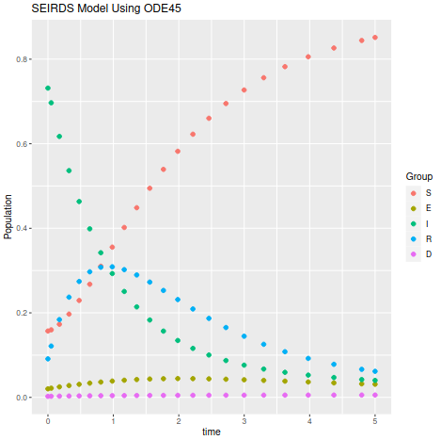

Weighted
Identical compartments to those displayed in Table 3.
Parameter | Derived Value
β
δ
Ɣ_{R}
Ɣ_{D}
μ
ϵ
ω

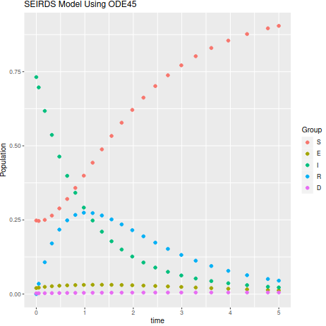

Conclusions and Future Works

References

