Lab 5. Gene expression Part 3: Feature Selection. We will use the major depressive disorder (MDD) RNA-Seq data to extend our use of basic statistics to statistical learning to perform feature selection, which is a more advanced way to identify genes that are differentially expressed between phenotype groups (e.g., between disease and healthy control). So far you have learned to normalize and transform data, filter genes based on variation, cluster subjects, perform differential expression using the t-test, and use a gene set enrichment analysis tool. In this lab, you will use the generalized linear model (GLM) called logistic regression, which allows you to include more sources of variation (covariates like sex) than the t-test. You will also use other machine learning feature selection methods.

Step 0. Process and filter data following previous labs.

# load gene expression data
load("sense.filtered.cpm.Rdata") # setwd!

# load phenotype (mdd/hc) data
subject.attrs <- read.csv("Demographic_symptom.csv",
stringsAsFactors = FALSE)
library(dplyr)
# grab intersecting X (subject ids) and Diag (Diagnosis) from columns
phenos.df <- subject.attrs %>%
filter(X %in% colnames(sense.filtered.cpm)) %>%
dplyr::select(X, Diag)
mddPheno <- as.factor(phenos.df$Diag)

# Normalized and transform
library(preprocessCore)
mddExprData_quantile <- normalize.quantiles(sense.filtered.cpm)
mddExprData_quantileLog2 <- log2(mddExprData_quantile)
# attach phenotype names and gene names to data
colnames(mddExprData_quantileLog2) <- mddPheno
rownames(mddExprData_quantileLog2) <- rownames(sense.filtered.cpm)

# coefficient of variation filter sd(x)/abs(mean(x))
CoV_values <- apply(mddExprData_quantileLog2,1,
function(x) {sd(x)/abs(mean(x))})
# smaller threshold, the higher the experimental effect relative to the
# measurement precision
sum(CoV_values<.045)
# there is one gene that has 0 variation -- remove
sd_values <- apply(mddExprData_quantileLog2,1, function(x) {sd(x)})
rownames(mddExprData_quantileLog2)[sd_values==0]
# filter the data matrix
GxS.covfilter <- mddExprData_quantileLog2[CoV_values<.045 & sd_values>0,]
dim(GxS.covfilter)

# convert phenotype to factor
pheno.factor <- as.factor(colnames(GxS.covfilter))
pheno.factor
str(pheno.factor)
levels(pheno.factor)

A . Logistic regression. Logistic regression estimates the beta parameters that minimize the following model fit to the outcome data (phenotype class, C). We choose to encode the MDD status as C=1 and HC status as C=0. This makes HC the reference level (baseline) so the probability means probability of being in the MDD class. The predictor variable is a gene G with an expression level x.

$$\text{log}\left(\frac{C=1∨G=x}{C=0∨G=x}\right)=β_{o}+β_{1}x$$

In the glm function, R chooses the reference level to be the first level of the factor. In pheno.factor, we want to use relevel to make sure the reference level is HC.

# make sure HC is the reference level
pheno.factor.relevel <- relevel(pheno.factor,"HC")
levels(pheno.factor.relevel)
# also rename levels "0"/"1" from 1/2
levels(pheno.factor.relevel)[levels(pheno.factor.relevel)=="MDD"] <- 1
levels(pheno.factor.relevel)[levels(pheno.factor.relevel)=="HC"] <- 0

Run the following code to fit a logistic model of the first gene (gene.row <- 2) to the phenotype data. 1. What are the coefficients for the slope and intercept of the model and their p-values? Based on the p-value of the slope, is this a good model?

gene.row <- 2
gene.name <-rownames(GxS.covfilter)[gene.row]
gene.expr <- GxS.covfilter[gene.row,]
gene.fit <- glm(pheno.factor.relevel~gene.expr, family=binomial)
summary(gene.fit)
coeff.mat <- coef(summary(gene.fit))
b0 <- coeff.mat[1,1]
b1 <- coeff.mat[2,1]
b1.pval <- coeff.mat[2,4]

1.
Estimate Std. Error z value Pr(>|z|)
(Intercept) -11.114125 7.780399 -1.428478 0.1531544
gene.expr 1.990687 1.394874 1.427144 0.1535384

P-Value is > 0.05. This is not a good model.

The equation below shows the logistic model that glm is fitting for the disease probability. Use the code below to show the probability predictions for this gene.

$$\text{probability(sample=MDD|gene2=x)}=\frac{1}{1+e^{−\left(β_{o}+β_{1}x\right)}}$$

modelfn <- function(x){1/(1+exp(-(b0+b1*x)))}
g.min <- min(gene.expr)
g.max <- max(gene.expr)
curve(modelfn,g.min,g.max) # plot for domain of actual gene’s expression
abline(h=.5, lty=2)
curve(modelfn,3,8) # replot with extended domain to see the S shape
abline(h=.5, lty=2)

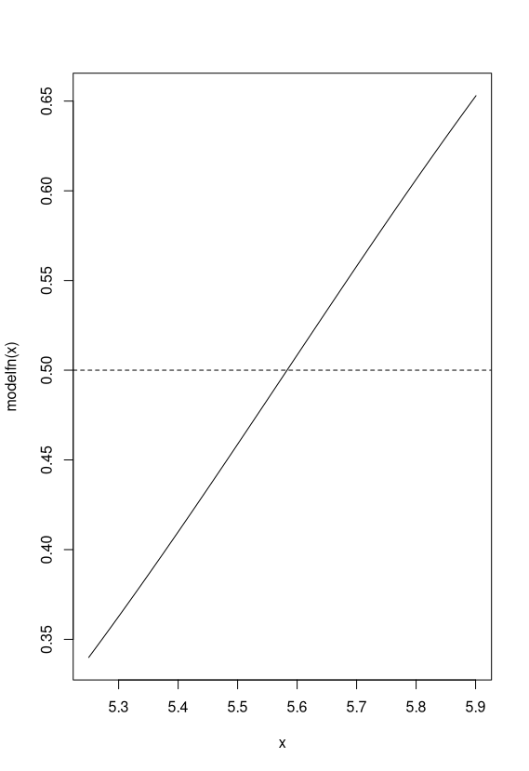
Another way to plot is to create the predicted probabilities from the model using the predict function. 2. Show the plots.

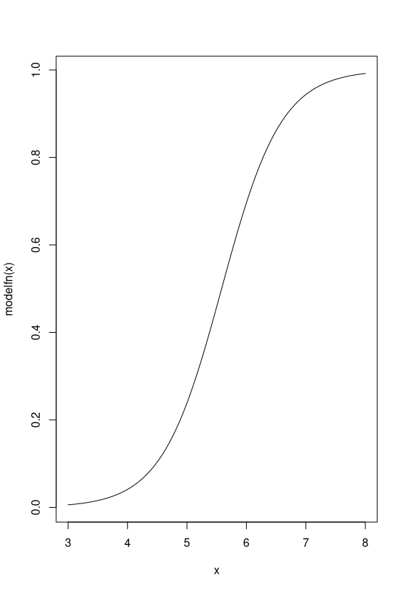

Predicted.probs <- predict(gene.fit, gene.expr=gene.expr,
type="response")
library(ggplot2)
phenotype <- pheno.factor # just rename for legend
gene.gg.df <- data.frame(expression=gene.expr,
prediction=predicted.probs)
# plot predicted probabilities versus gene expression
p <- ggplot(data=gene.gg.df)
p <- p + geom_point(aes(x=expression,
y=prediction,
color=phenotype, # shape and color
shape=phenotype), # are true phenotype
size=3)
p <- p + geom_hline(yintercept = .5, linetype="dashed", color="red")
print(p)

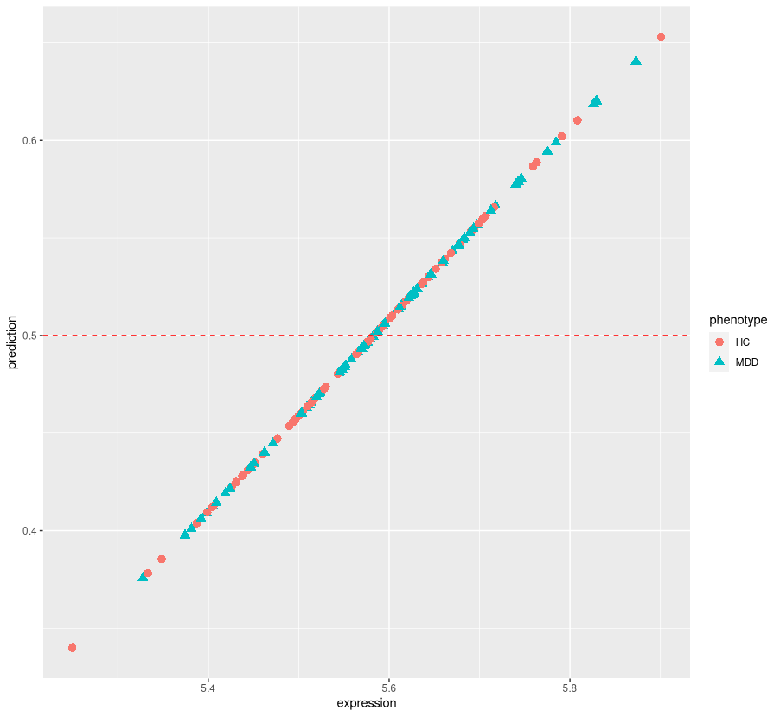

B. Logistic regression as classification. Often logistic regression is used for inferential statistics, meaning it is used to find variables that are important for understanding something about the phenotype. However, it can also be used as a classifier (to predict whether a sample is in one group or another). The R function predict, used above, returns the probability (predicted.probs) of samples being Class=1 (MDD) given the fitted model parameters (gene.fit) and input expression levels of the samples (gene.expr).

Run the code below. 3. What rule is used in the code to determine whether a sample is predicted to be MDD? How does the rule relate to the ggplot above? How many samples are predicted to be MDD? How many samples are correctly classified? 4. Add code to calculate the classification accuracy (the number of correctly classified samples divided by the number of samples). Sum the correctly classified samples (correct.classified) and divide by the number of samples. Does this gene lead to a good classifier? (As a reference, a bad classifier would be flipping a coin, which would have 50% accuracy on average).

# vector of logistic output probabilities for this model (glm/eq. above)
# prob = .5 is the threshold for prediction class = 1 vs 0
predicted.class <- as.integer(predicted.probs >=.5) # predicted class
pheno.factor.relevel # true class
# vector of True (correctly predicted) and False (wrongly predicted)
correct.classified <- predicted.class == pheno.factor.relevel
# sum correct.classified
table(pheno.factor.relevel,predicted.class)

3. Part A computes a list of predicted probabilities. For this part, the R code uses the predicted probabilities, and checks each value. A boolean check is performed on each value to determine if it is greater than or equal to 0.5. This boolean check is then converted to an integer. If it’s greater than or equal to 0.5, it returns a predicted class of “1” (MDD), otherwise it returns a predicted class of 0 (HC).

4.
# accuracy:
correct.acc <- sum(correct.classified == "TRUE") / length(correct.classified)
> correct.acc
[1] 0.5414013

This is slightly better than a bad classifier.

C. Logistic regression ranking of all genes. The code below writes a function to compute the glm statistics for a gene (row i) of the data matrix, then uses a for loop to create a data frame of results for all genes.

# logistic regression function for one gene row
lr.fn <- function(i){
gene=rownames(GxS.covfilter)[i]
gene.expr <- GxS.covfilter[i,]
gene.fit <- glm(pheno.factor.relevel~gene.expr,
family=binomial)
coeff.mat <- coef(summary(gene.fit))
b1 <- coeff.mat[2,1]
b1.pval <- coeff.mat[2,4]
coefvec <- gene.fit$estimate # intercept, gene
pvec <- gene.fit$p.value # intercept, gene
c(gene, b1, b1.pval)
}

Run the function for gene row 2. 5. What does the function output?

lr.fn(2)

5.
> lr.fn(2)
[1] "AAK1" "1.99068675569476" "0.153538361756257"
Outputs the gene name, the intercept, and its p-value.

Apply the function to all genes below and sort the results. 6. Show the top 10 genes from lr.results.sorted.

# initialize results matrix
num.genes<-nrow(GxS.covfilter)
lr.results.mat <- matrix(0, nrow=nrow(GxS.covfilter), ncol=3)
# for loop the function to all genes
for (i in 1:num.genes){
lr.results.mat[i,] <- lr.fn(i)
}
lr.results.df <- data.frame(lr.results.mat)
colnames(lr.results.df) <- c("gene", "b1", "p.val")

# sort results b1 coefficient p-value
library(dplyr)
lr.results.sorted <- lr.results.df %>%
mutate_at("p.val", as.character) %>%
mutate_at("p.val", as.numeric) %>%
arrange(p.val)
lr.results.sorted[1:10,]

6.
gene b1 p.val
1 MDGA1 3.27222557173125 4.917554e-05
2 ZDHHC20 3.44752422025746 1.664413e-04
3 NPFF -4.93598819959299 2.931886e-04
4 IRF2BPL 4.02807033481586 3.994416e-04
5 ARFGAP1 4.50243248968137 4.083146e-04
6 FAM138A -3.90725563811716 4.308357e-04
7 UBD 2.02594802661092 4.757671e-04
8 BCL2L12 3.55042230110901 6.054376e-04
9 POGZ -3.36092614792741 6.196730e-04
10 ZFP36L2 2.62332879572813 6.232671e-04

7. Use the code from A to create a ggplot scatter plot of the logistic regression model fit and compute the accuracy for the top gene. First we need to get the row index of the top gene:

gene.row <- which(rownames(GxS.covfilter)=="ENTER TOP GENE NAME HERE")
gene.expr <- GxS.covfilter[gene.row,]
gene.fit <- glm(pheno.factor.relevel~gene.expr,
family=binomial)
predicted.probs <- predict(gene.fit, gene.expr=gene.expr, type="response")
# Add Plotting Code
# Add code for accuracy

7.
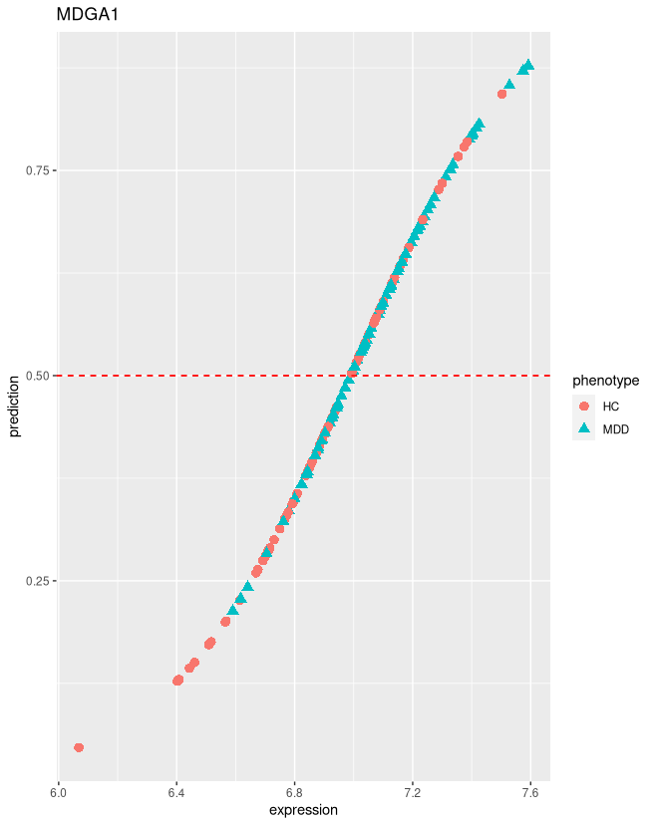

Extra note. Here is how to compute a false discovery adjusted P-value from the original/raw P-values.

# adjusted p-value
lr.padj <- p.adjust(lr.results.sorted$p.val, method="BH")
lr.results.sorted$p.adj <- lr.padj
lr.results.sorted[1:45,]

> correct.acc
[1] 0.6242038

D. Statistical Learning. The following code uses GLMnet, which is a library for penalized logistic regression/classification. The regression model includes all of the genes at once and uses a penalty to help remove irrelevant variables. GLMnet combines both Ridge and Lasso when 0<alpha<1. GLMnet uses cross-validation (CV) to tune the amount of overall penalty (lambda). Penalized regression forces many of the coefficients to be zero.

library(glmnet) # install.packages("glmnet")

# alpha=0 means ridge, alpha=1 means lasso
# keep has to do with storing the results from cross-validiation
glmnet.model <- cv.glmnet(t(GxS.covfilter), pheno.factor.relevel, alpha=1,
family="binomial", type.measure="class", keep=T)
plot(glmnet.model) # plot of CV error vs lambda penalty
glmnet.model$lambda.min # lambda that minimizes the CV error

8. From the code above, show the CV plot. What is the lambda that minimizes the CV error? Show the genes with non-zero (important) coefficients and the classification accuracy. The accuracy is higher than regular glm logistic regression we used earlier because it is using many genes in the model and there is probably some overfitting.

8.

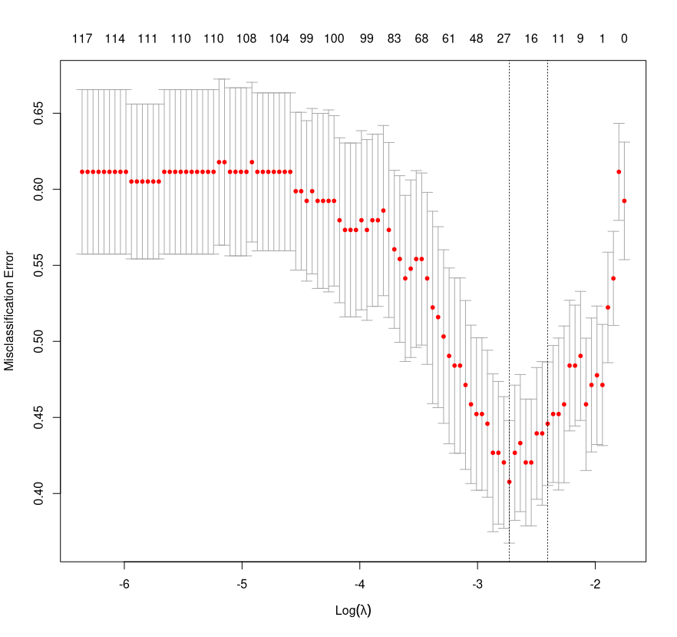

lambda that minimizes CV error: 0.06521466

genes with non-zero coefficients:
“Easy” way with
if (!require("coefplot")) install.packages("coefplot")
library(coefplot)
extract.coef(glmnet.model)

> extract.coef(glmnet.model)
Value SE Coefficient
(Intercept) 15.32081869 NA (Intercept)
ALAS1 0.11502152 NA ALAS1
ATXN7L2 0.07594971 NA ATXN7L2
C16orf74 0.50393920 NA C16orf74
DLEC1 -0.55011200 NA DLEC1
ELP3 -0.58275685 NA ELP3
EXOSC3 -0.10808390 NA EXOSC3
FAM138A -0.40964781 NA FAM138A
IRF2BPL 0.06336807 NA IRF2BPL
MDGA1 1.03735782 NA MDGA1
MEN1 -0.43343899 NA MEN1
NPFF -0.48181494 NA NPFF
OSBPL3 -1.86605893 NA OSBPL3
PANX1 -1.11155374 NA PANX1
POGZ -0.01244924 NA POGZ
PPP2R5C -0.02285152 NA PPP2R5C
PSMG3 -0.03391447 NA PSMG3
RASA1 -0.62975277 NA RASA1
TUSC3 0.68148987 NA TUSC3
UBD 0.33308961 NA UBD
UPK1A -0.38450494 NA UPK1A
VDAC3 -0.36955140 NA VDAC3
YAP1 -0.03868904 NA YAP1
ZCWPW1 0.58062073 NA ZCWPW1
ZDHHC20 0.33022555 NA ZDHHC20

Or, from given code:
> glmnet.nonzero.coeffs
[1] "(Intercept)" "ALAS1" "ATXN7L2" "C16orf74" "DLEC1"
[6] "ELP3" "EXOSC3" "FAM138A" "IRF2BPL" "MDGA1"
[11] "MEN1" "NPFF" "OSBPL3" "PANX1" "POGZ"
[16] "PPP2R5C" "PSMG3" "RASA1" "TUSC3" "UBD"
[21] "UPK1A" "VDAC3" "YAP1" "ZCWPW1" "ZDHHC20"

classification accuracy: 0.8152866

# get the penalized regression coefficients
glmnet.coeffs <- predict(glmnet.model,type="coefficients",
s=glmnet.model$lambda.min)

# get the coefficients that are not zero (these are the selected variables)
#glmnet.nonzero.coeffs <- #glmnet.coeffs@Dimnames[[1]][which(glmnet.coeffs!=0)]
#glmnet.nonzero.coeffs

top_glmnet <- data.frame(as.matrix(glmnet.coeffs)) %>%
tibble::rownames_to_column(var = "features") %>%
filter(s1!=0, features!="(Intercept)")

top_glmnet_features <- top_glmnet %>% pull(features)

# apply the glmnet model to the data to get class predictions
glmnet.predicted <- predict(glmnet.model,
s=glmnet.model$lambda.min, # lambda to use
type="class", # classify
newx=t(GxS.covfilter)) # apply to original
glmnet.accuracy <- mean(factor(glmnet.predicted)==pheno.factor.relevel)
glmnet.accuracy
table(glmnet.predicted,pheno.factor.relevel) # confusion matrix

Optional. LASSO does not use a P-value to rank important genes. However, it is multivariate, does automatic feature selection and reduces the number of correlated variables. How does the number of genes selected by LASSO compare with a false discovery rate adjusted P-value of the univariate P-values? Use R’s p.adjust to selected the top group of adjusted P-values from the univariate P-values, lr.results.sorted.

D. Nearest Neighbor Projected Distance Regression (NPDR) is a feature selection algorithm that uses nearest neighbors in the full gene space to identify important genes that may influence due to interactions with other genes. It also has a pseudo p-value for statistical significance. 9. Install and run NPDR and show the top genes with false discovery rate adjusted p-value less than .05.

# for devtools, install Rtools (Windows program) and restart Rstudio
install.packages("devtools")
library(devtools)
install_github("insilico/npdr")

library(npdr) #https://github.com/insilico/npdr
SxG.dat <- t(GxS.covfilter)
npdr.MDD.results <- npdr(pheno.factor, SxG.dat,
regression.type="binomial",
attr.diff.type="numeric-abs",
nbd.metric = "manhattan",
knn=knnSURF.balanced(pheno.factor, sd.frac = .5),
dopar.nn = F, dopar.reg=F,
padj.method="bonferroni", verbose = T)
colnames(npdr.MDD.results) # column names of the output

library(dplyr)
# gets genes (attributes/att) with FDR-adjusted p-value<.05
top.p05.npdr <- npdr.MDD.results %>% filter(pval.adj<.05) %>% pull(att)

10. Use the code below to print the top 200 genes and see what pathways are enriched (MSigDB Reactome web service). What are the top pathways? In MSigDB, change “with FDR q-value less than” from .05 to 1.

# grab top 200, remove NA, remove "", get att col
top.npdr <- npdr.MDD.results %>% dplyr::slice(1:200) %>%
filter(att!="") %>% pull(att)

write.table(top.npdr,row.names=F,col.names=F,quote=F)

